Tour ID: 239753  
Tour Name: Iceland's Magical Northern Lights (2024)

Tour destinations: ['Reykjavik', 'Thingvellir National Park', 'Geysir', 'Gullfoss', 'Vik', 'Jokulsarlon', 'Skaftafell', 'Blue Lagoon']

Tour destinations images:

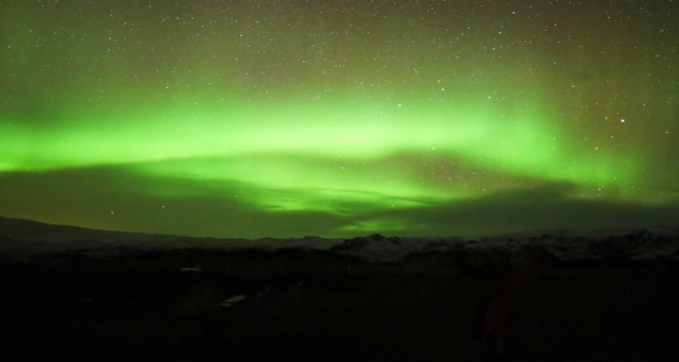

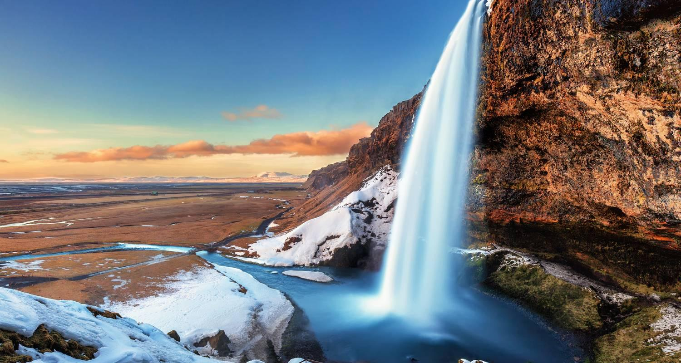

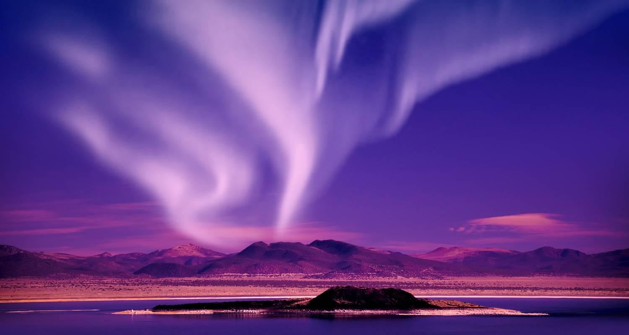

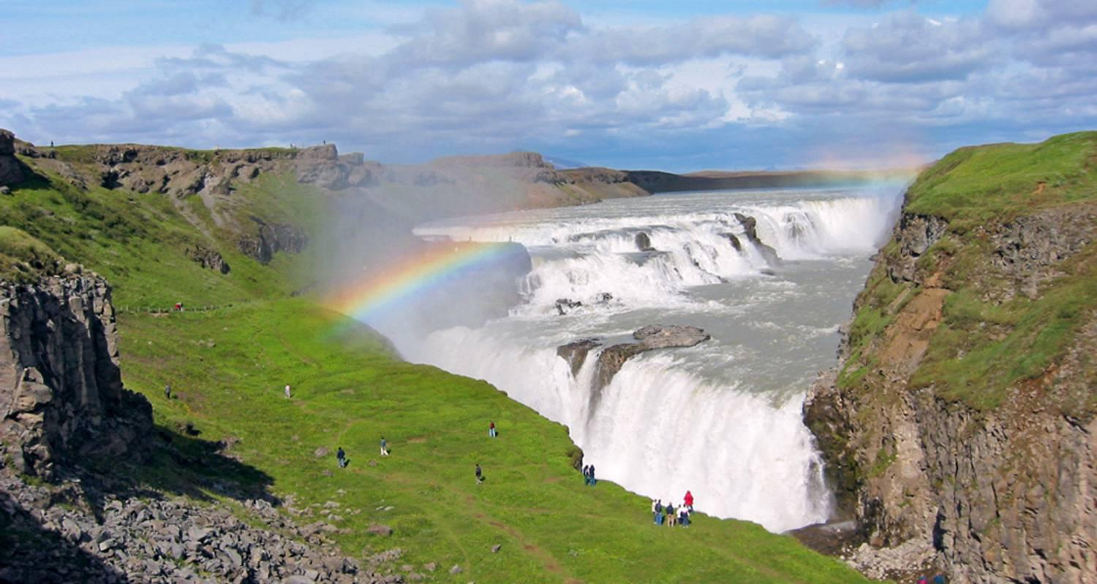

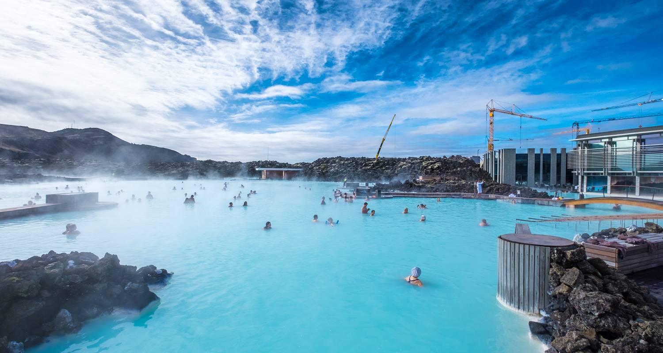

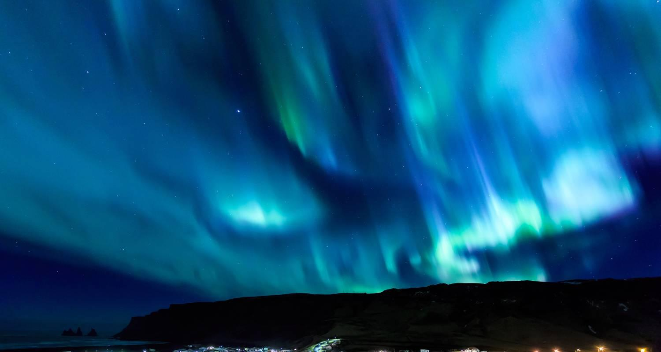

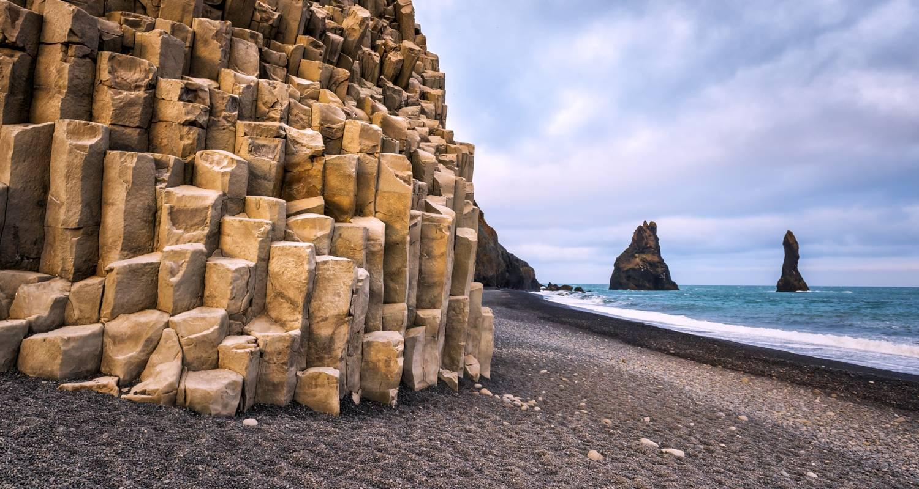

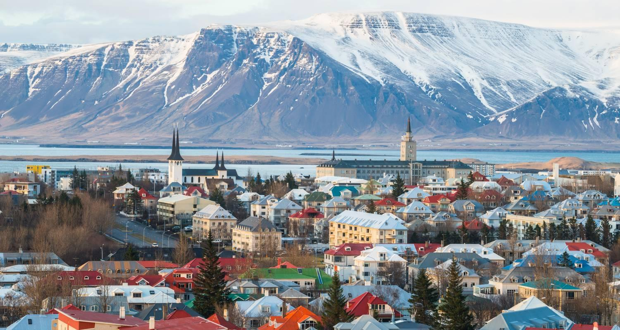

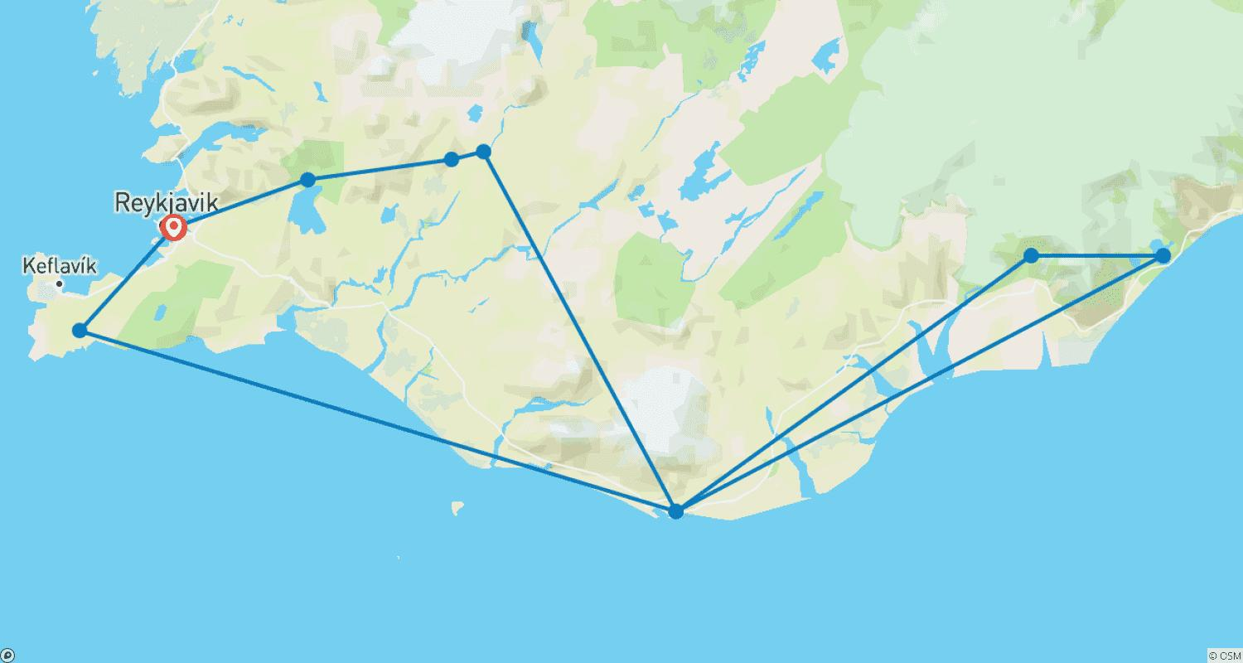

Tour ID: 239933  
Tour Name: Three Days in Iceland: Reykjavik & Snæfellsnes Peninsula

Tour destinations: ['Reykjavik', 'Snæfellsnes']

Tour destinations images:

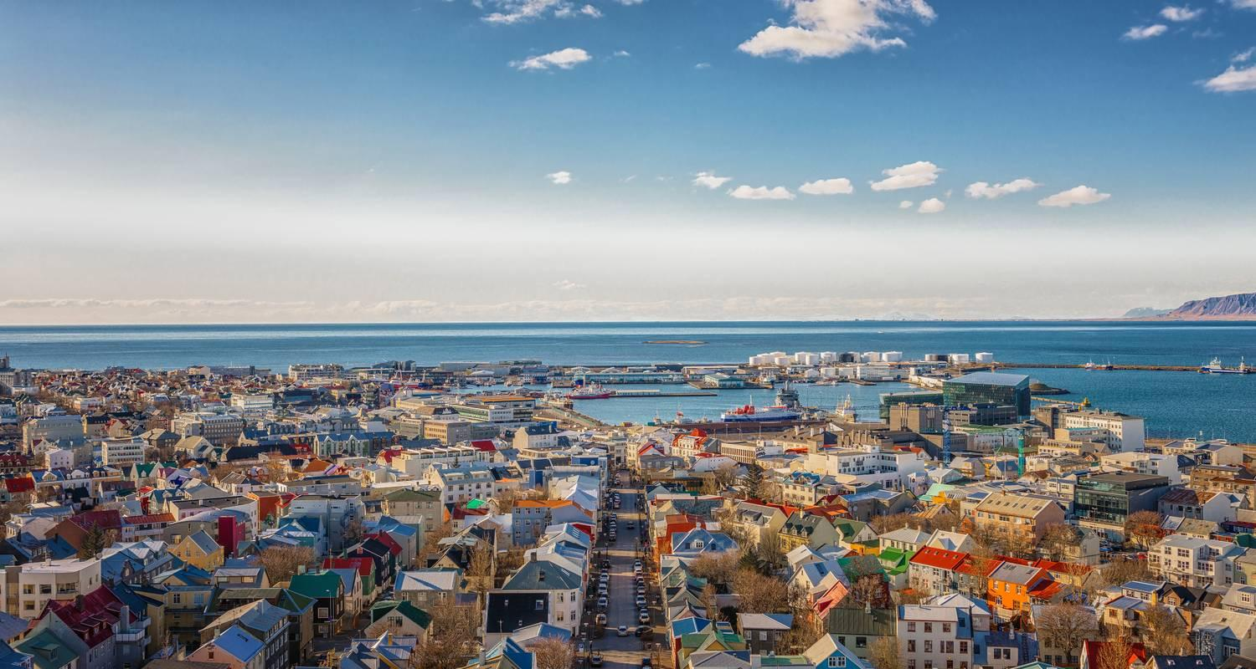

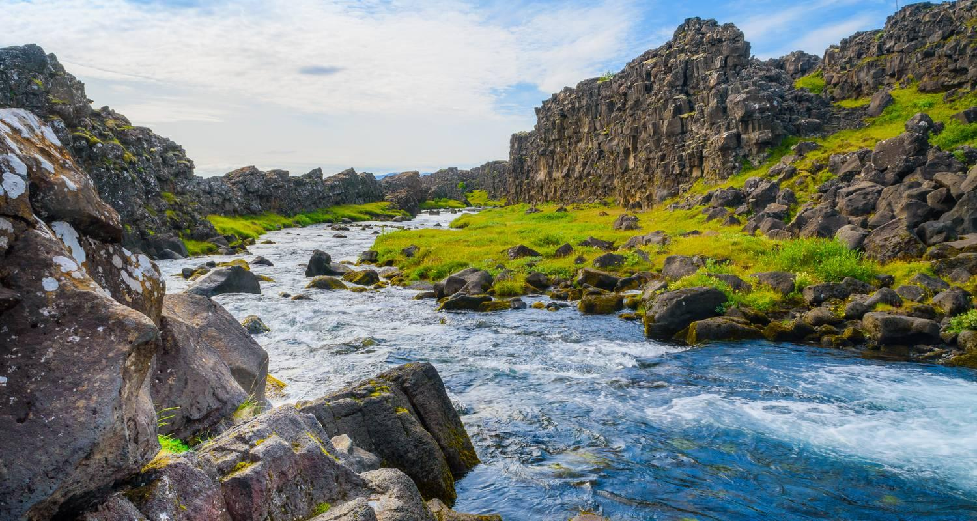

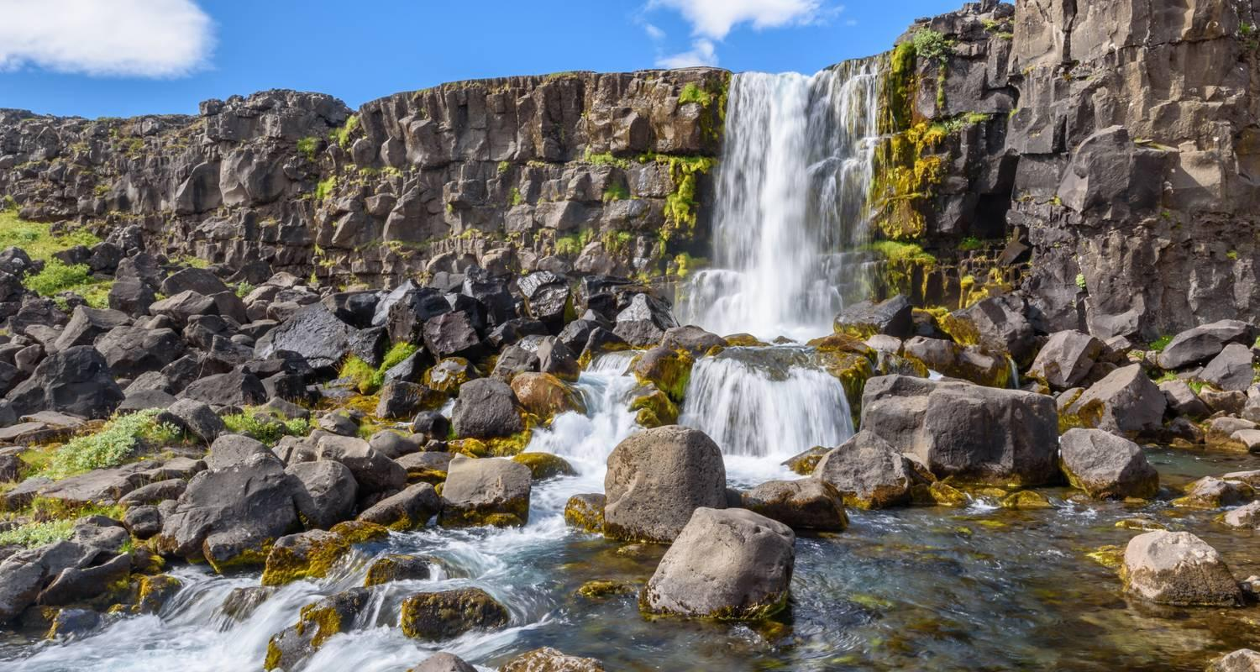

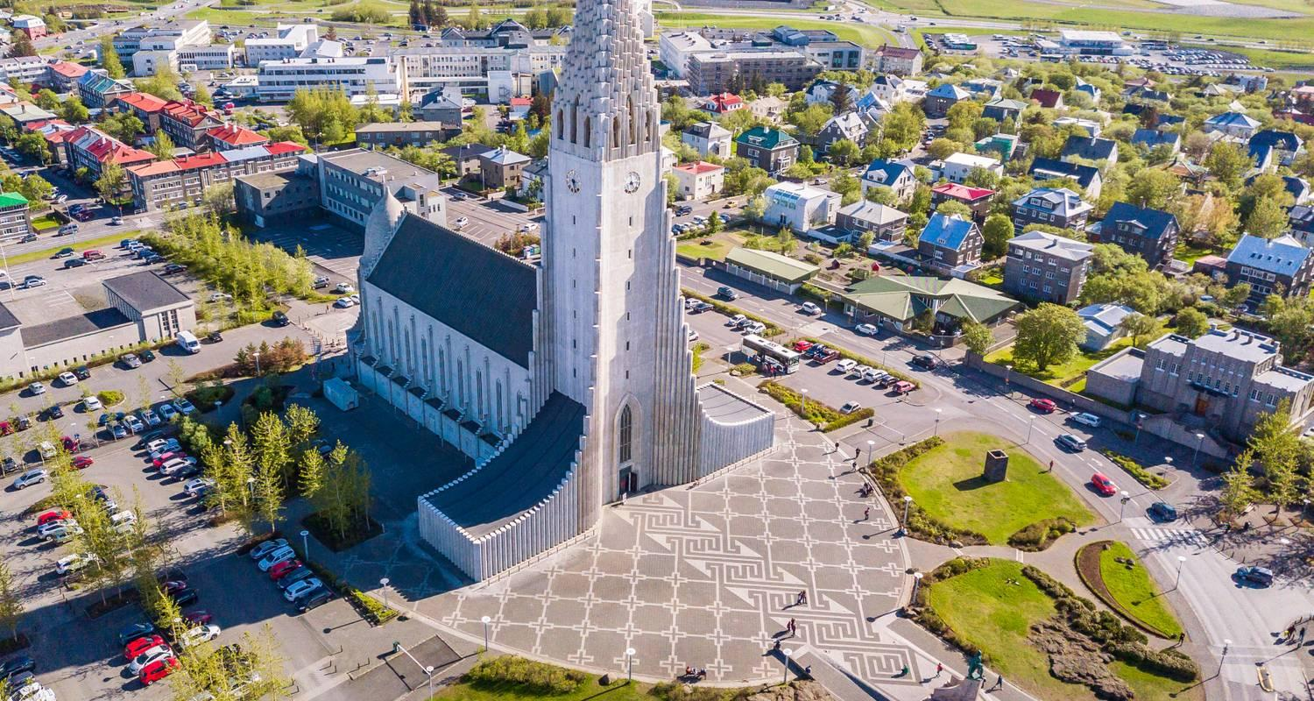

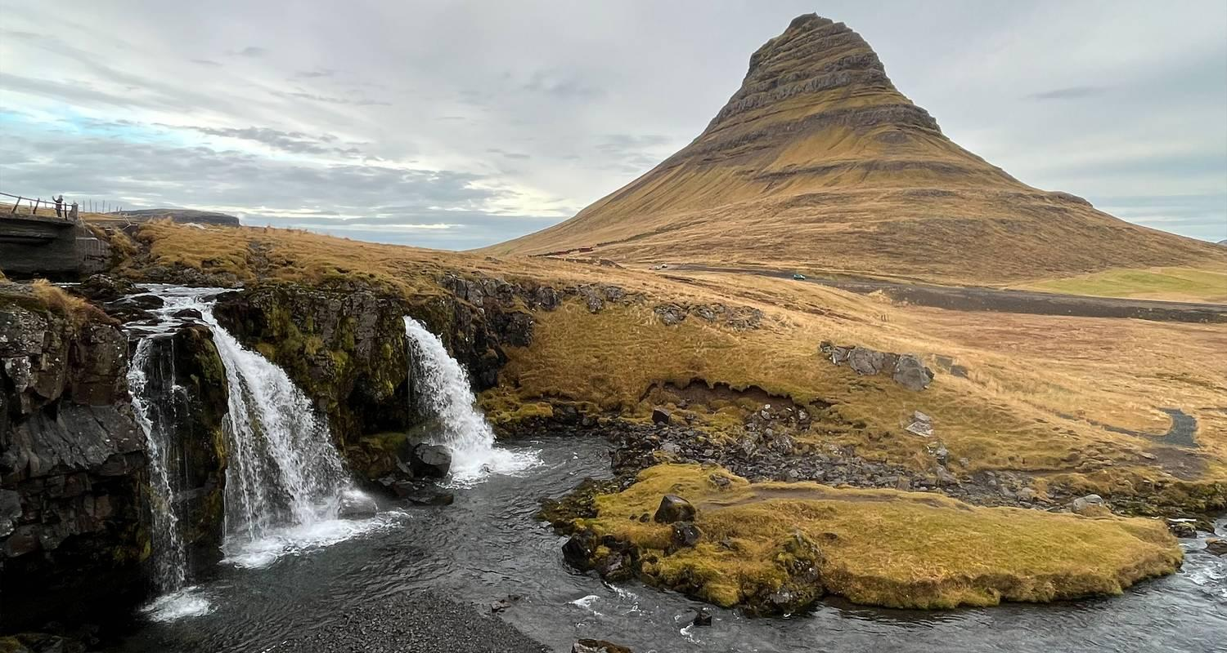

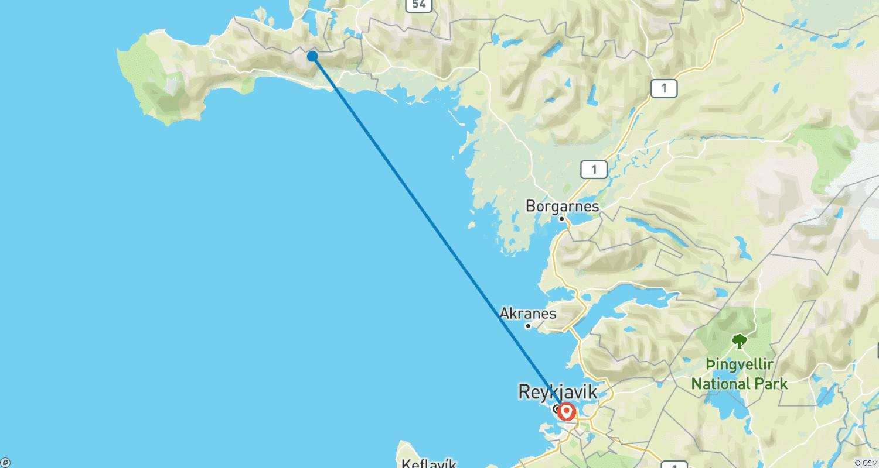

Tour ID: 239934  
Tour Name: Best of Iceland: Golden Circle & Snæfellsnes Peninsula

Tour destinations: ['Reykjavik', 'Akureyri', 'Bakkagerdi', 'Hofn', 'Vik', 'Snæfellsnes']

Tour destinations images:

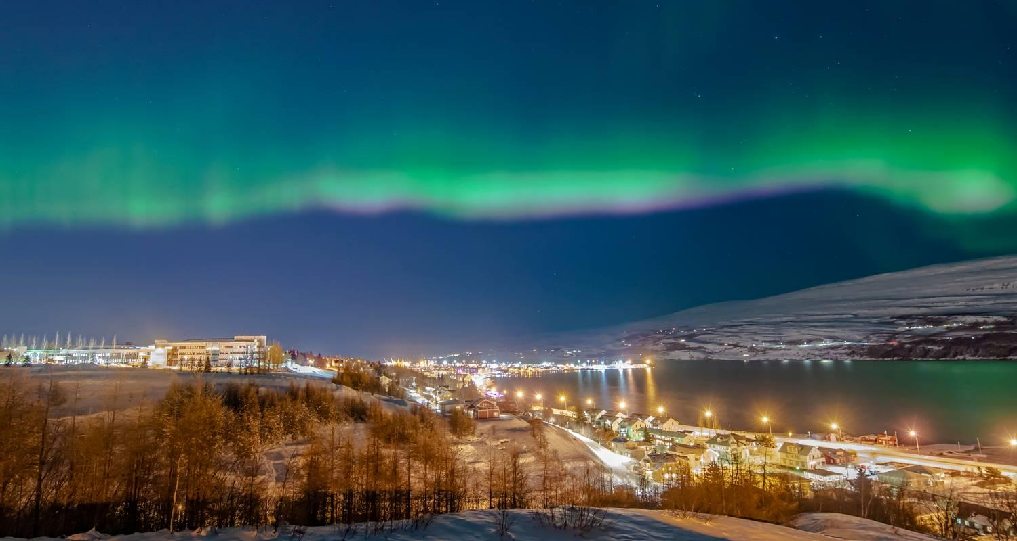



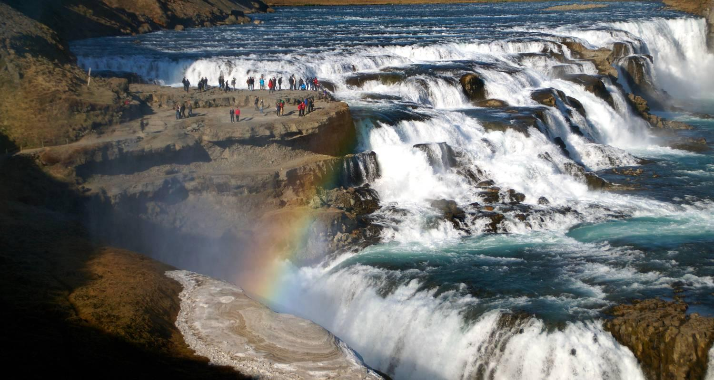

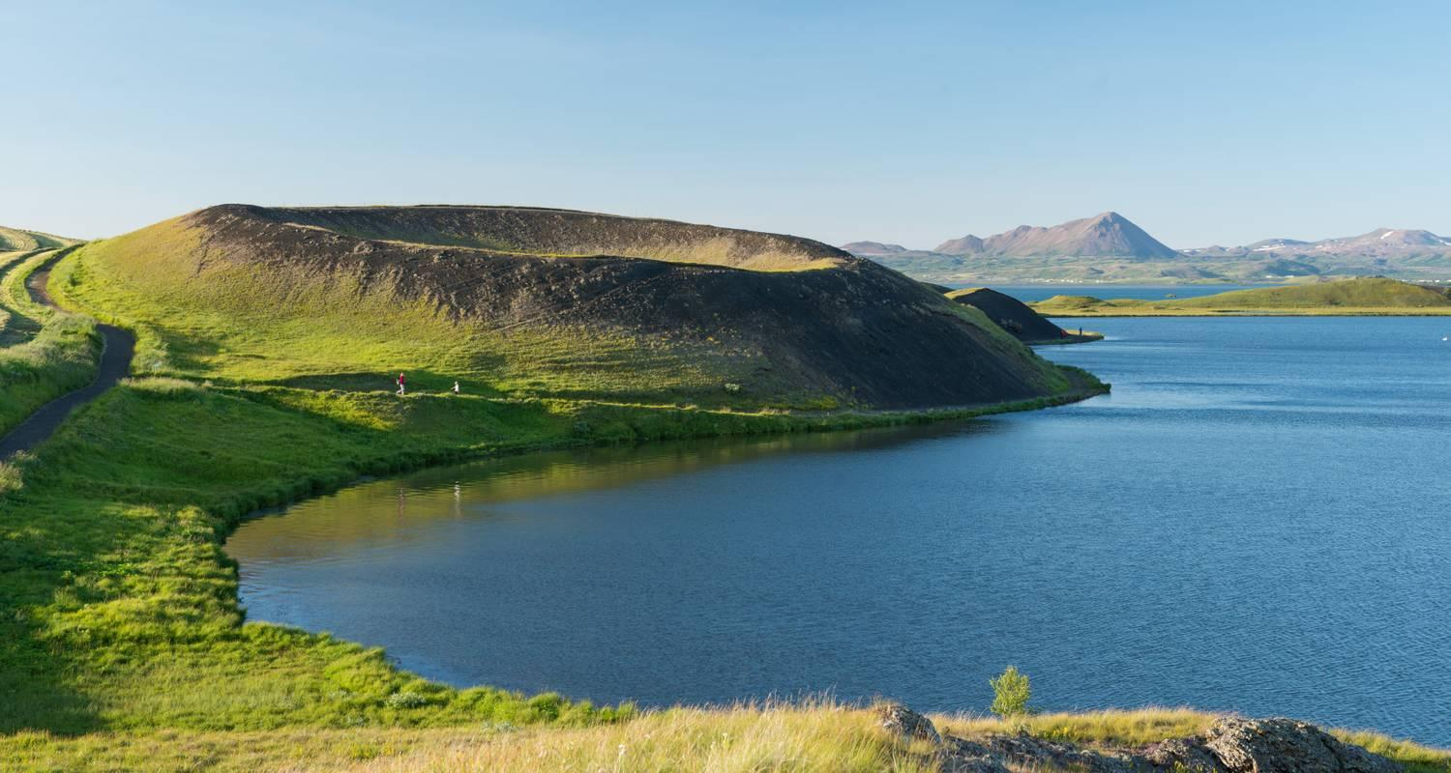

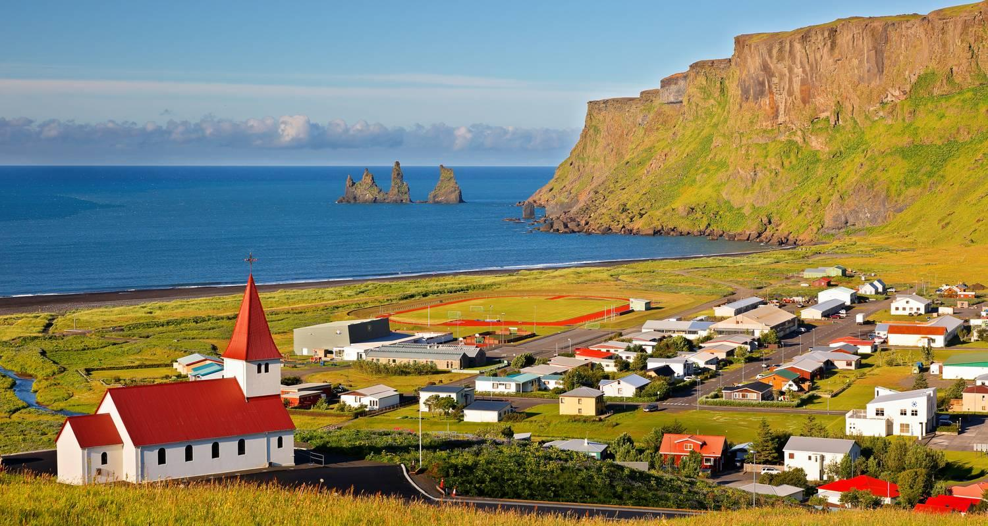

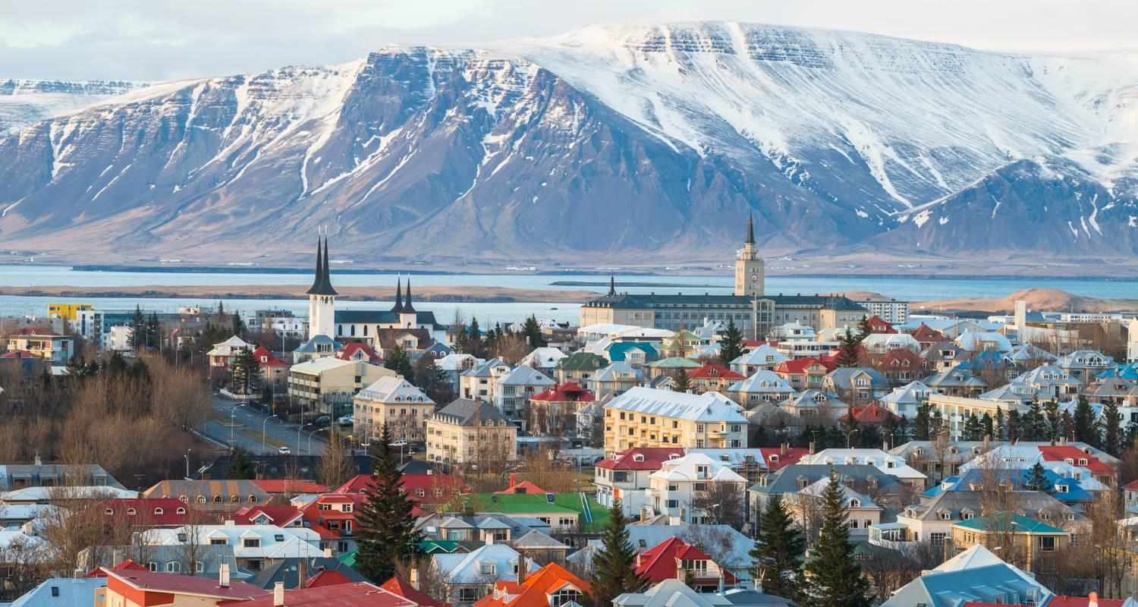

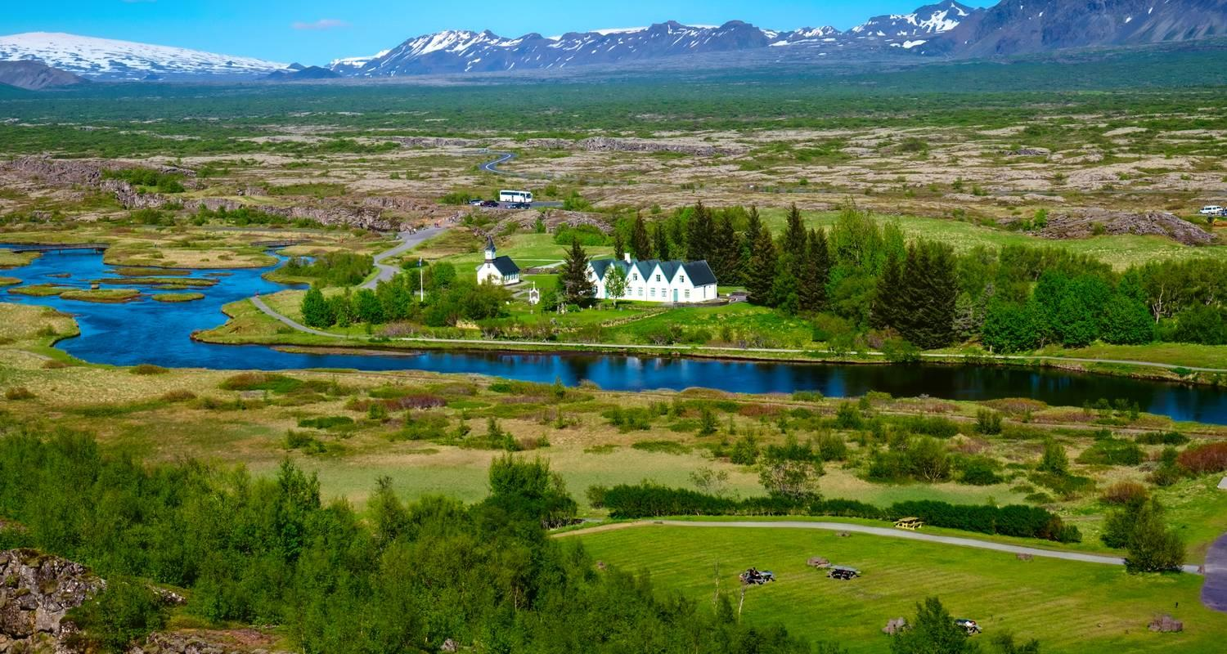

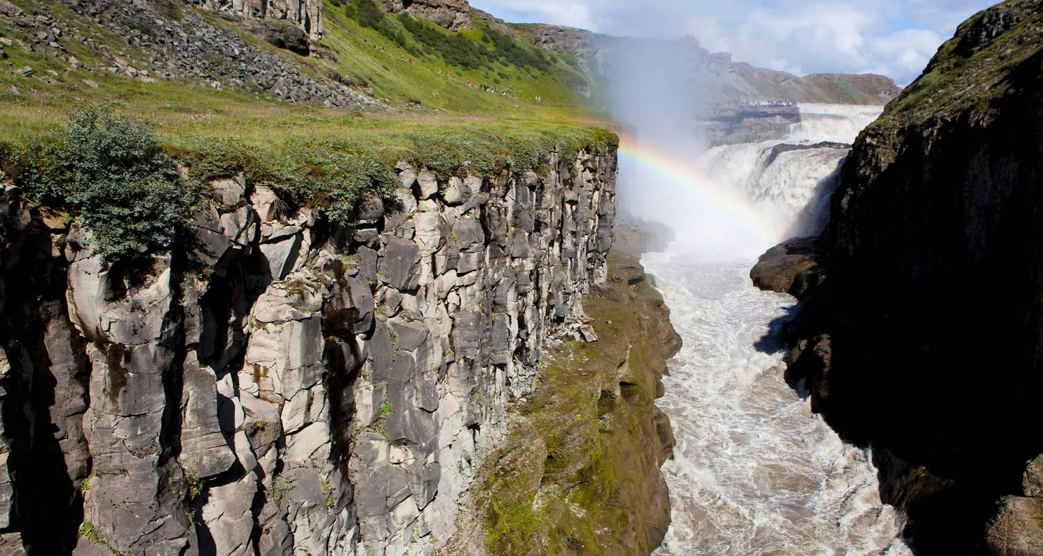

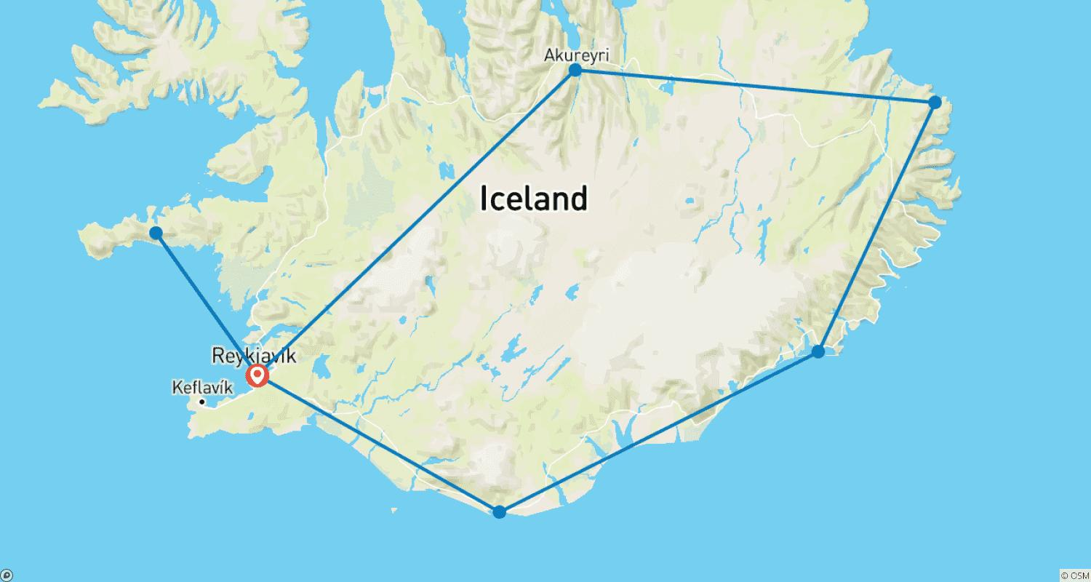

Tour ID: 239935  
Tour Name: Iceland Adventure: Northern Lights & Snæfellsnes Peninsula

Tour destinations: ['Reykjavik', 'Thingvellir National Park', 'Geysir', 'Gullfoss', 'Snæfellsnes']

Tour destinations images:



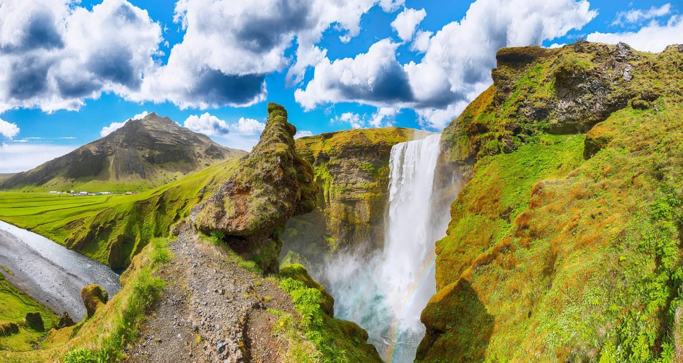



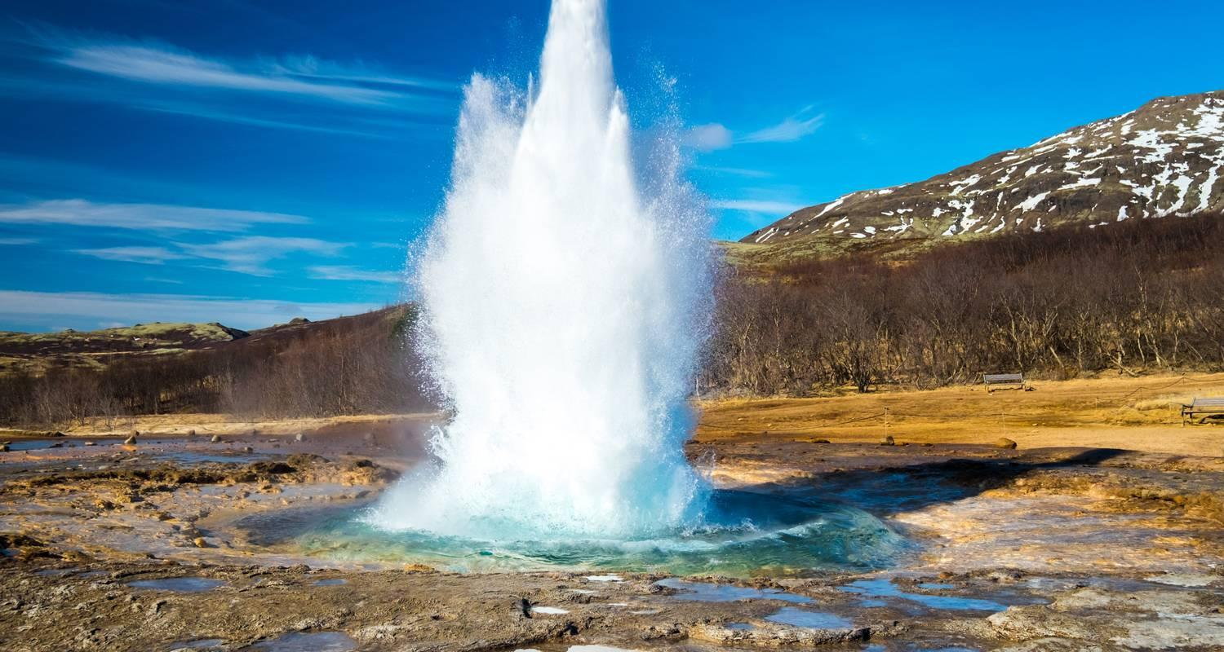

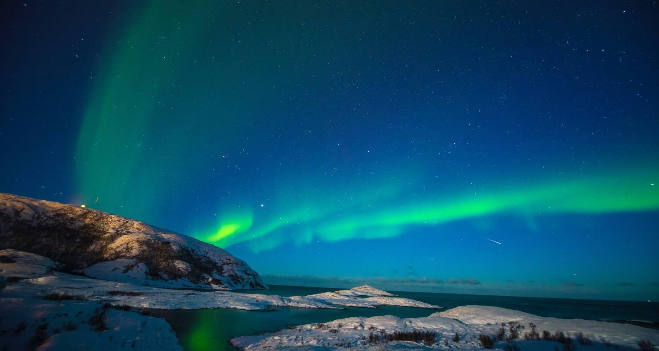

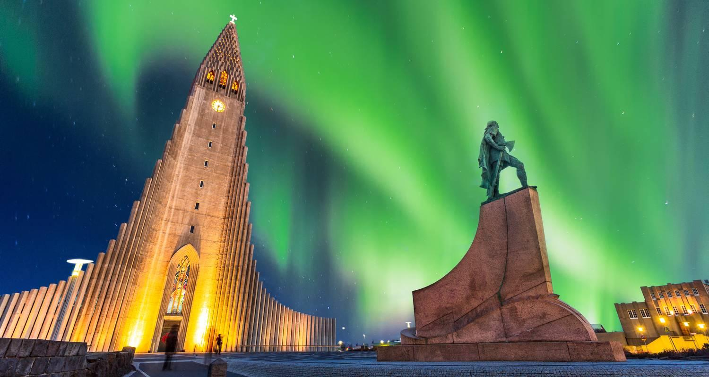



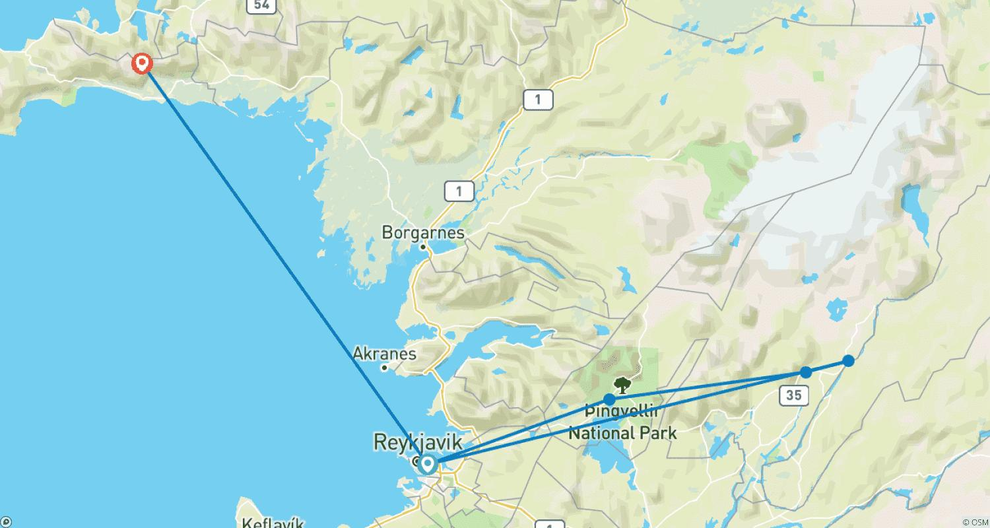

Tour ID: 240048  
Tour Name: Iceland in 6 Days

Tour destinations: ['Reykjavik']

Tour destinations images:

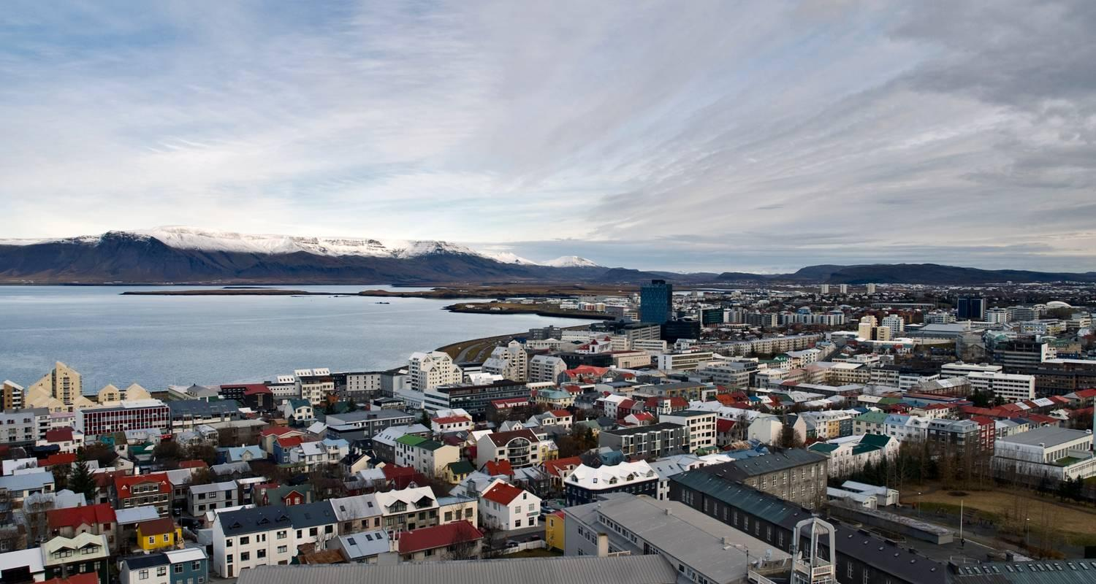

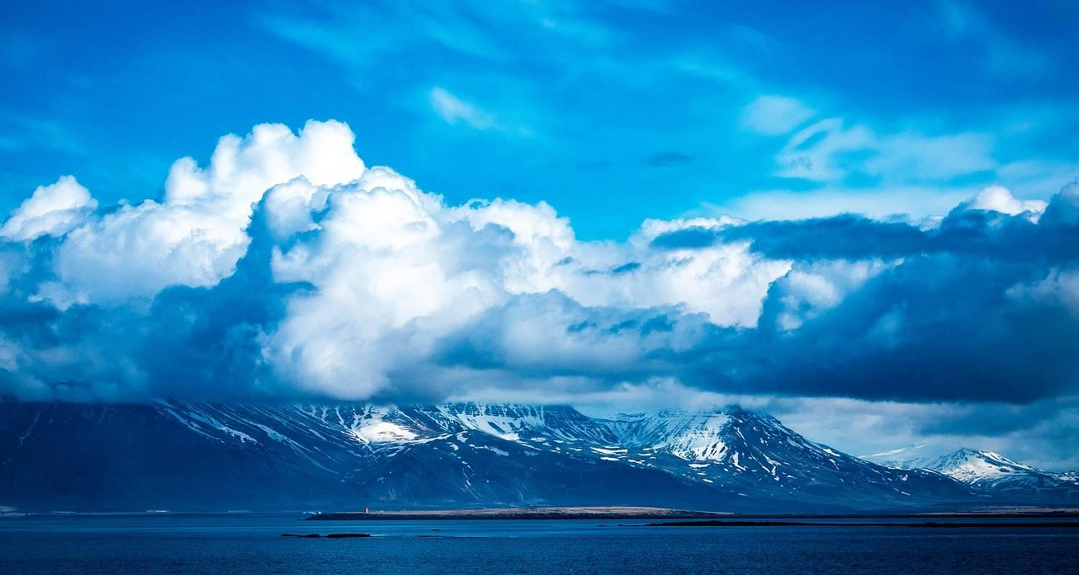

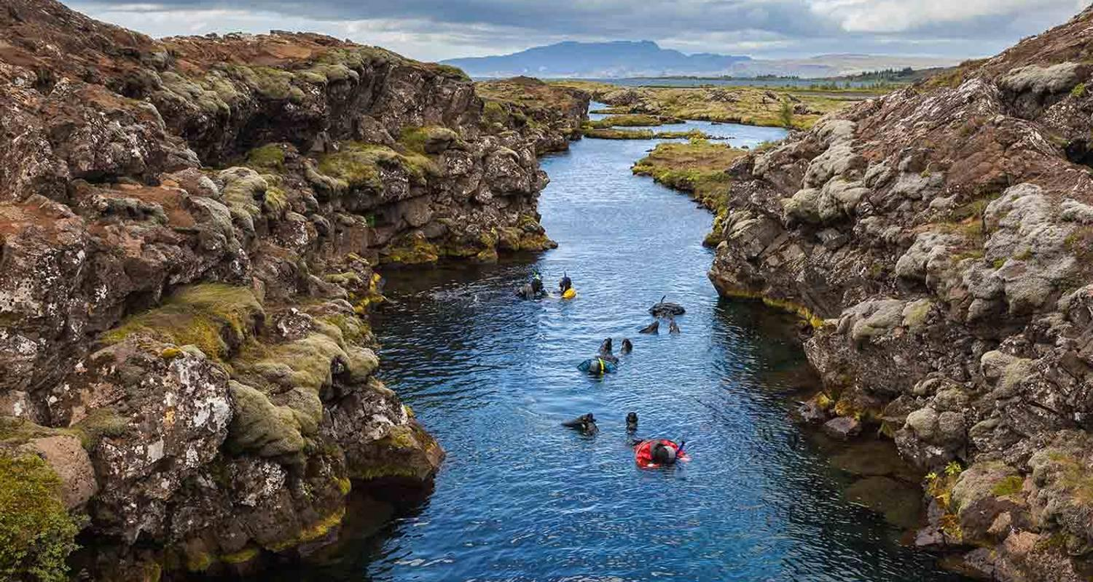

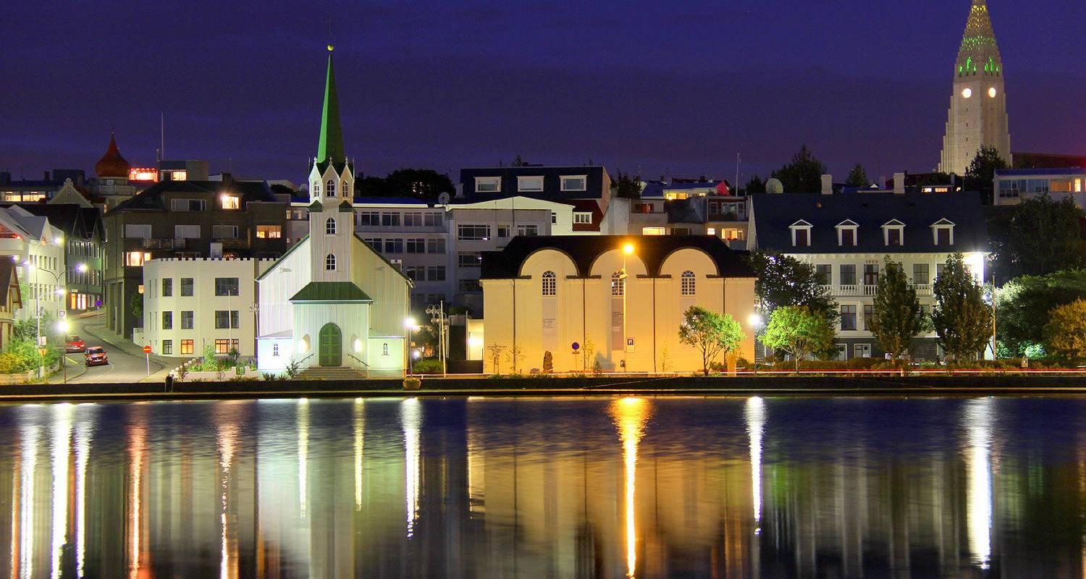

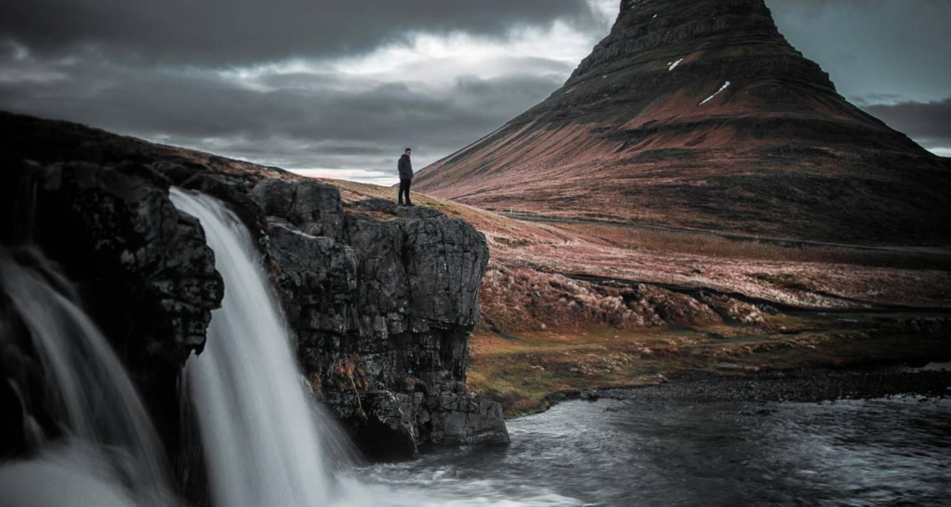

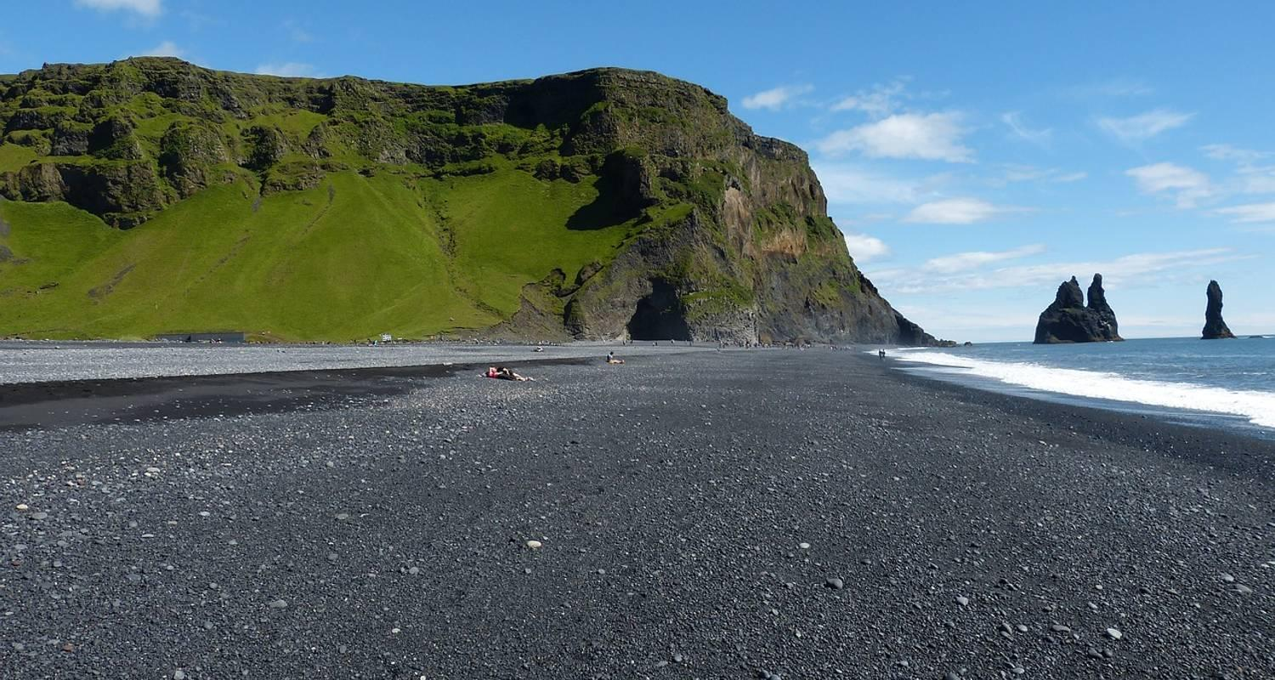

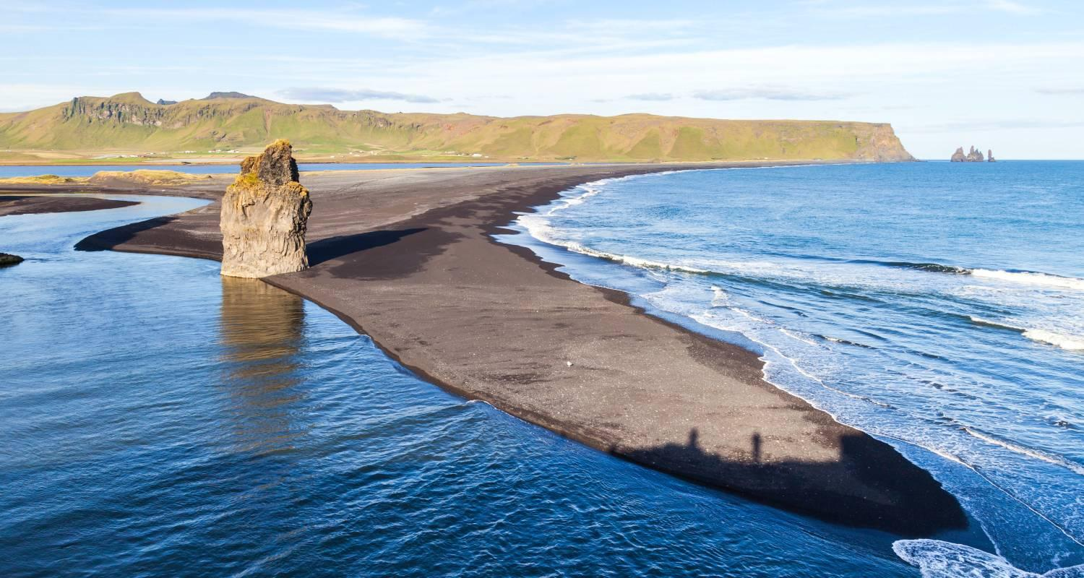

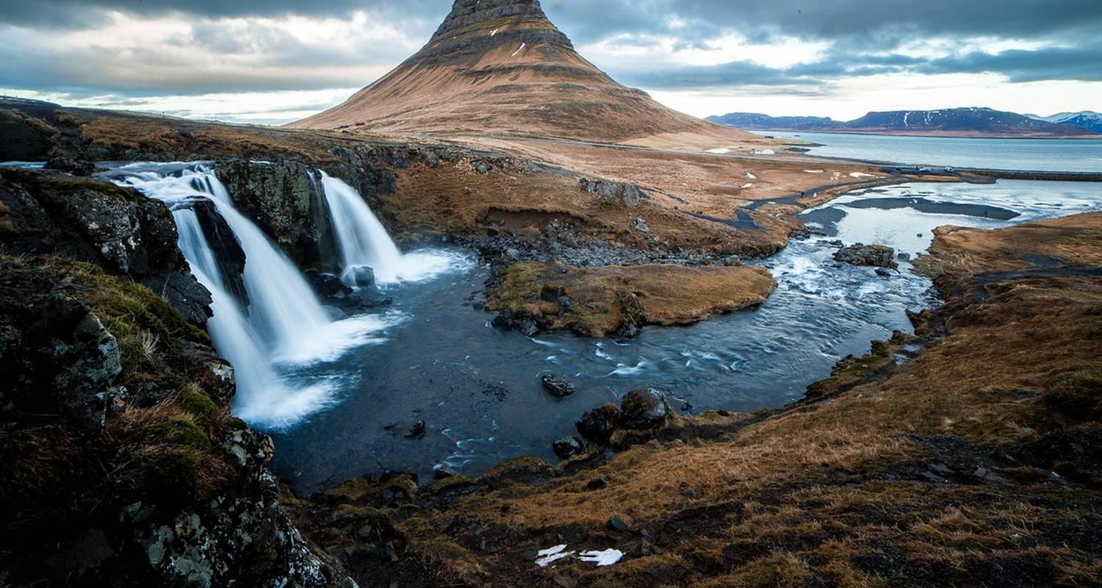

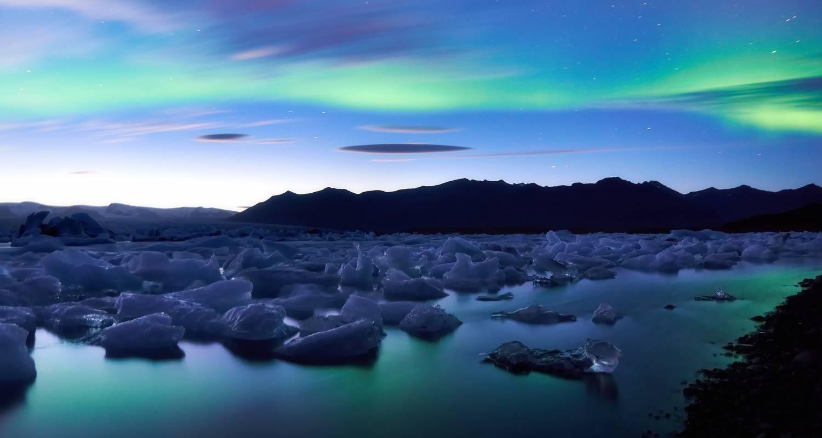

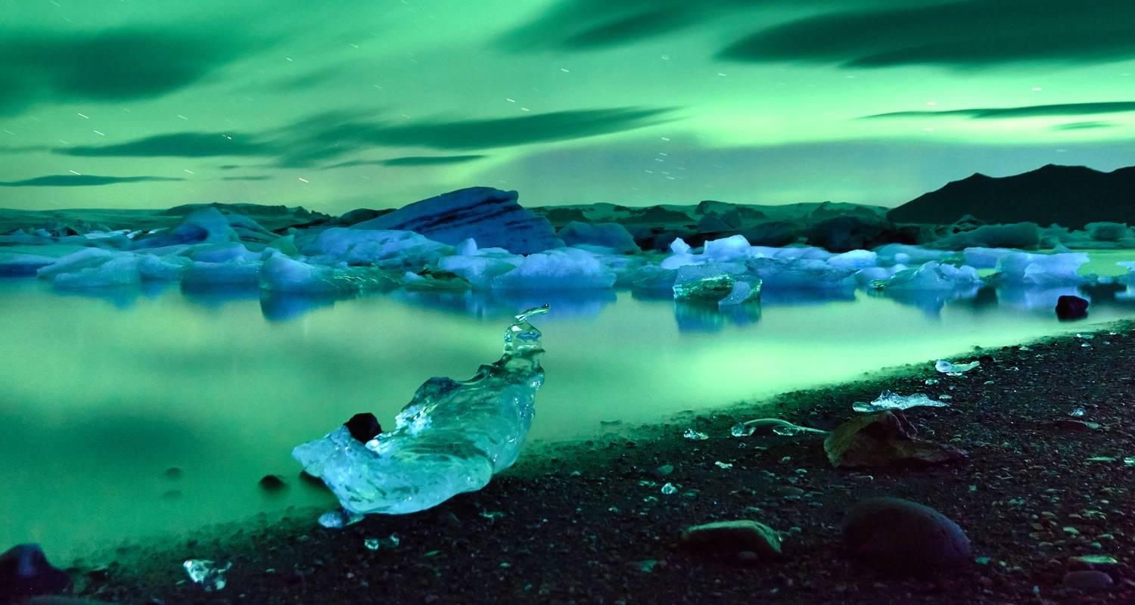

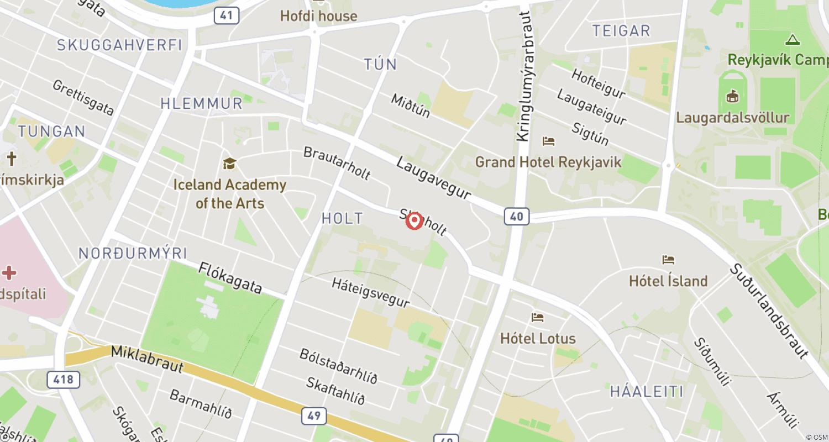

Tour ID: 240742  
Tour Name: Iceland: Land of Fire & Ice (2024)

Tour destinations: ['Reykjavik', 'Snæfellsnes', 'Stykkisholmur', 'Breidafjordur', 'Skogar', 'Solheimajokull', 'Vik', 'Jokulsarlon', 'Vatnajokull National Park', 'Seljaland']

Tour destinations images:

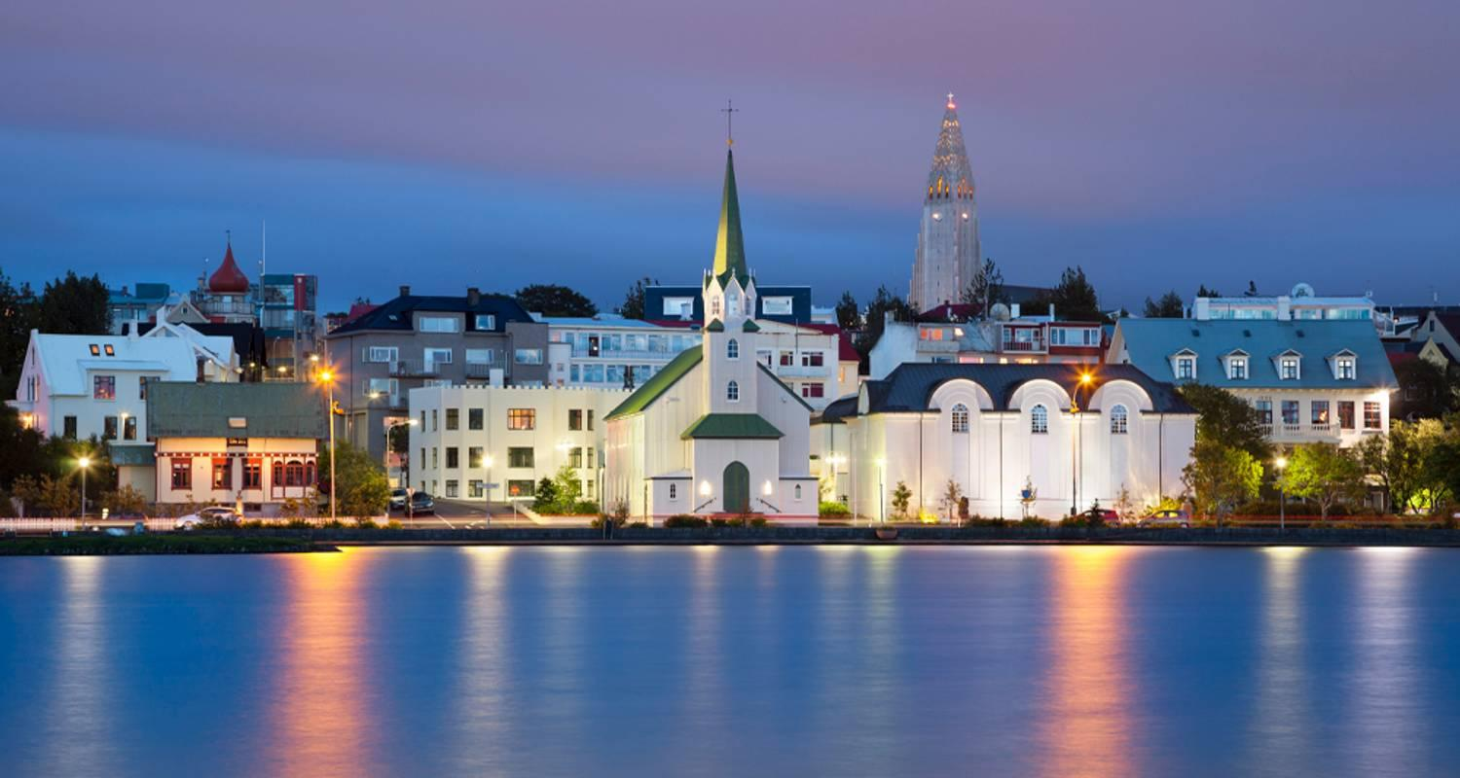

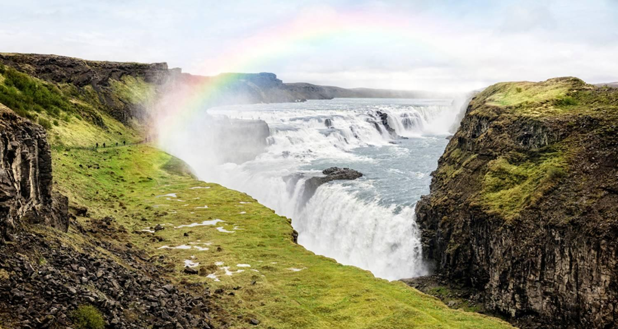

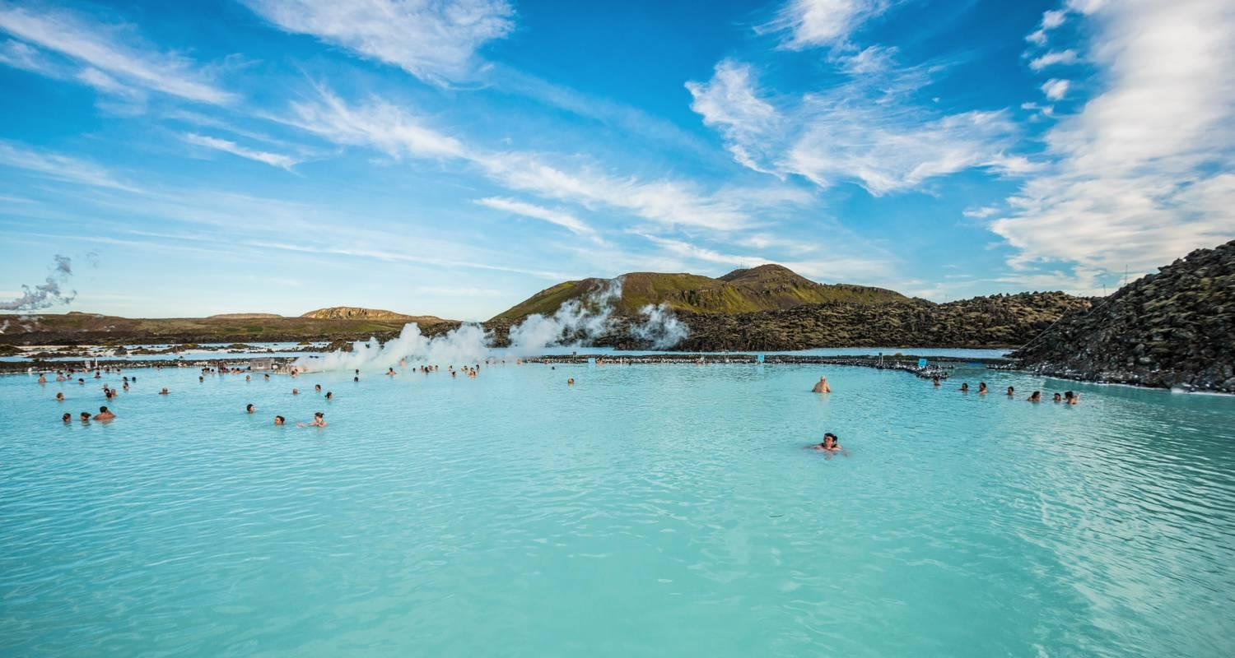

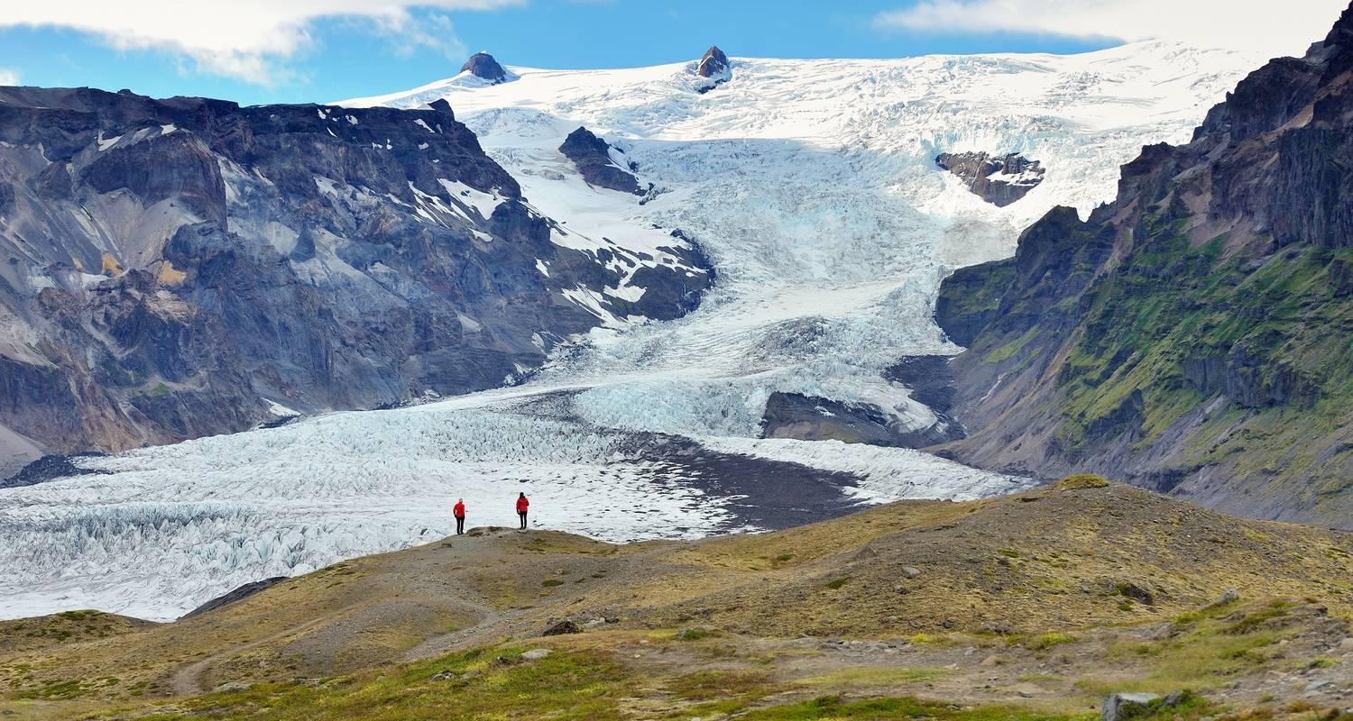

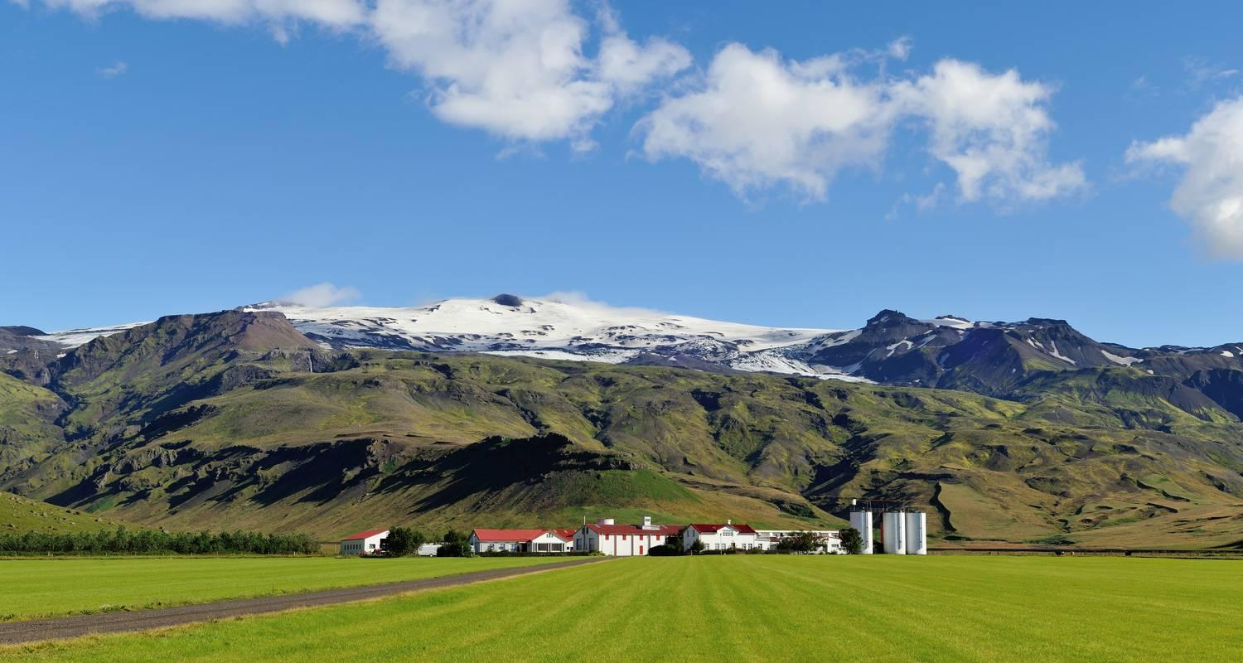

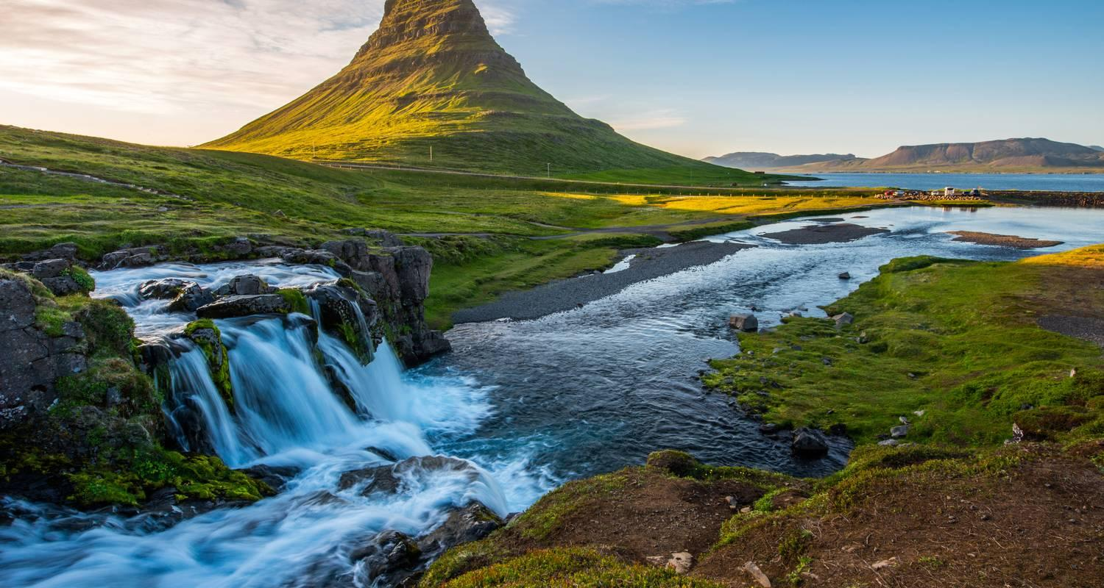



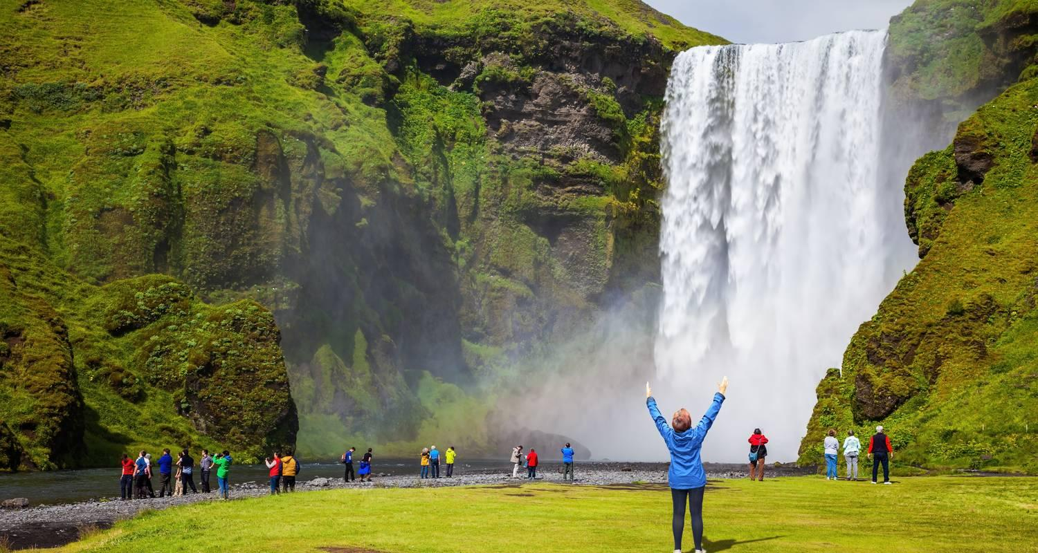

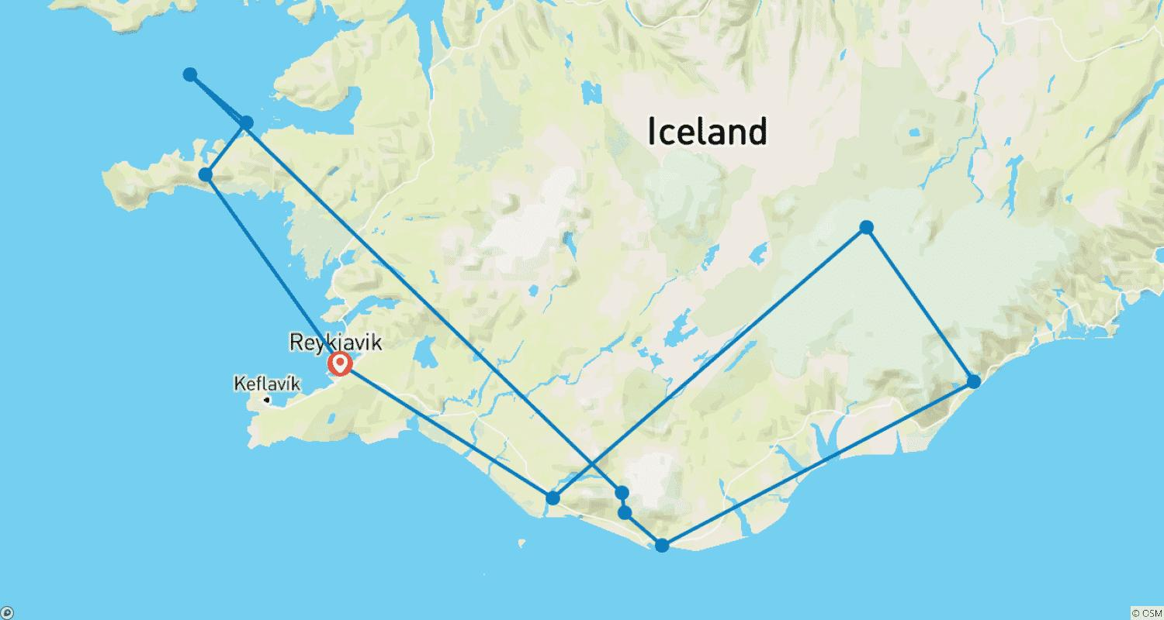

Tour ID: 240792  
Tour Name: Icelandic Explorer - 10 days/9 nights

Tour destinations: ['Reykjavik', 'Borgarnes', 'Reykholt', 'Hraunfossar', 'Akureyri', 'Godafoss', 'Myvatn', 'Hverarönd', 'Dettifoss', 'Modrudalur', 'Husavik', 'Djupivogur', 'Hofn', 'Hof', 'Skaftafell', 'Reynisfjara', 'Skogafoss', 'Blue Lagoon', 'Gullfoss', 'Geysir']

Tour destinations images:

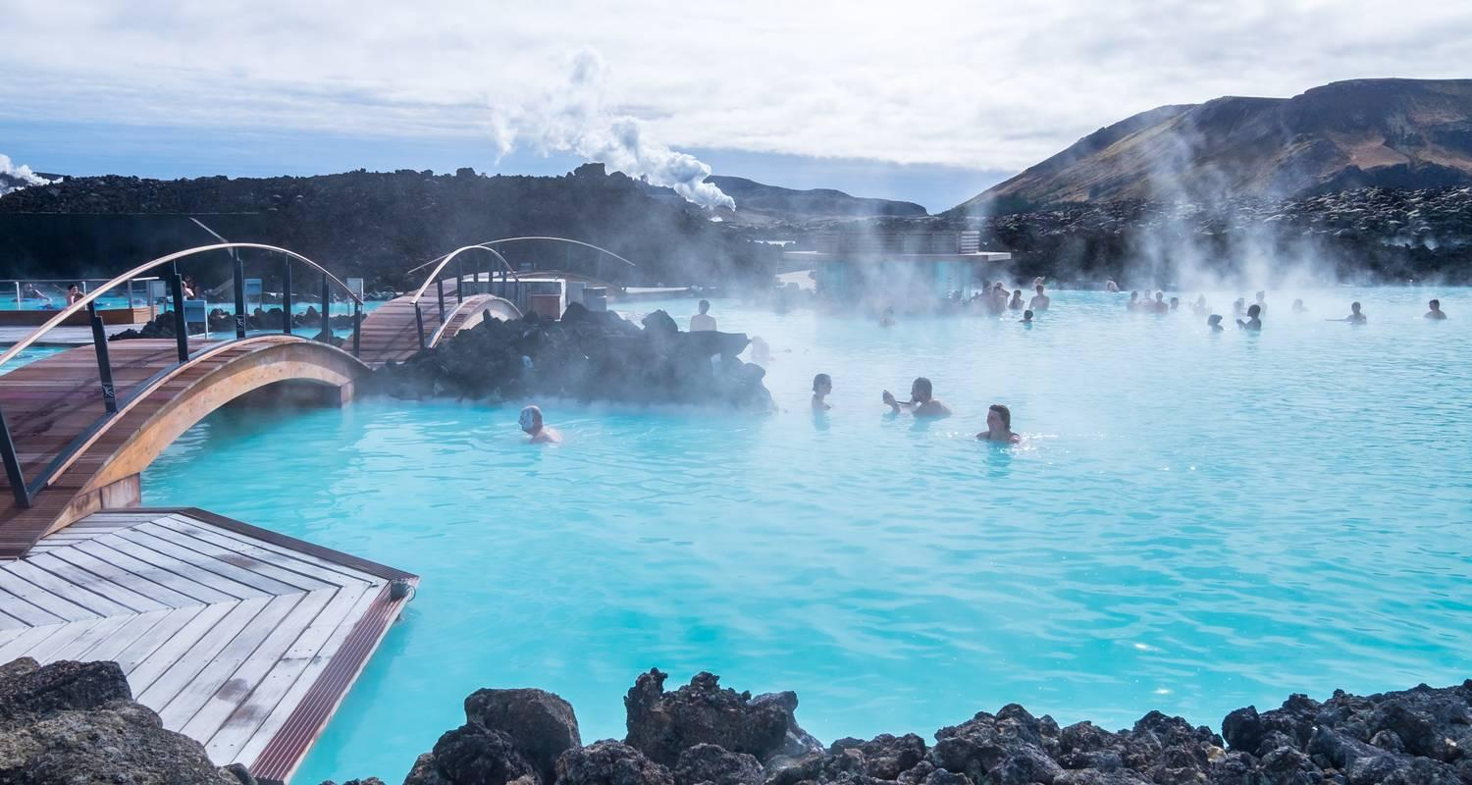

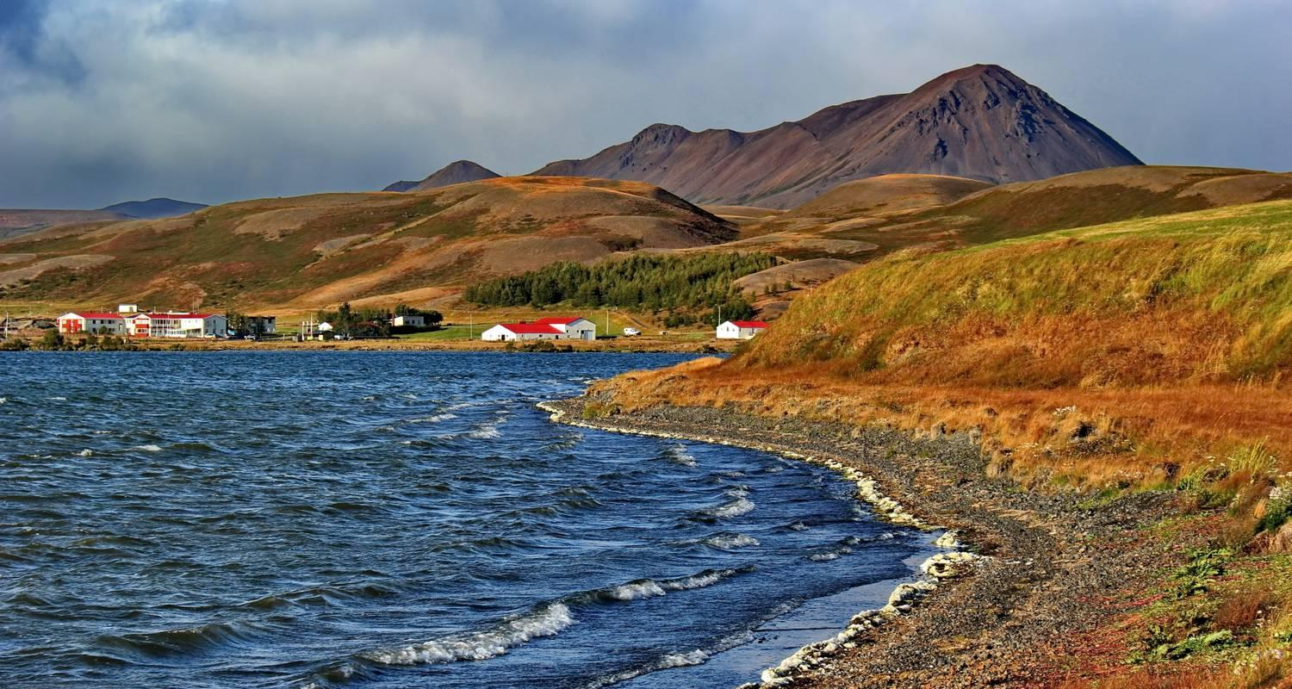

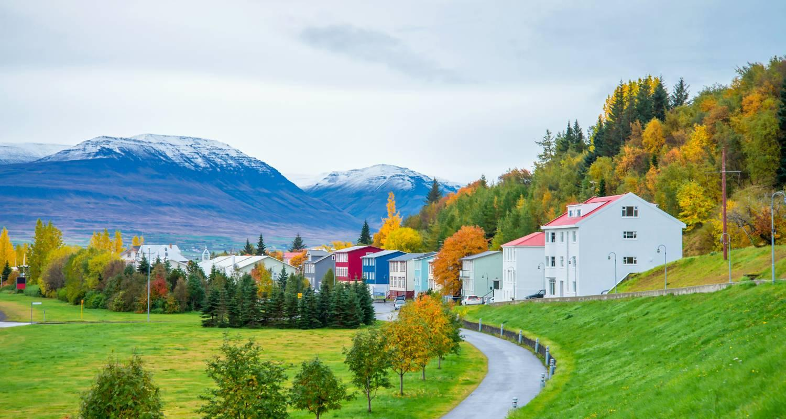

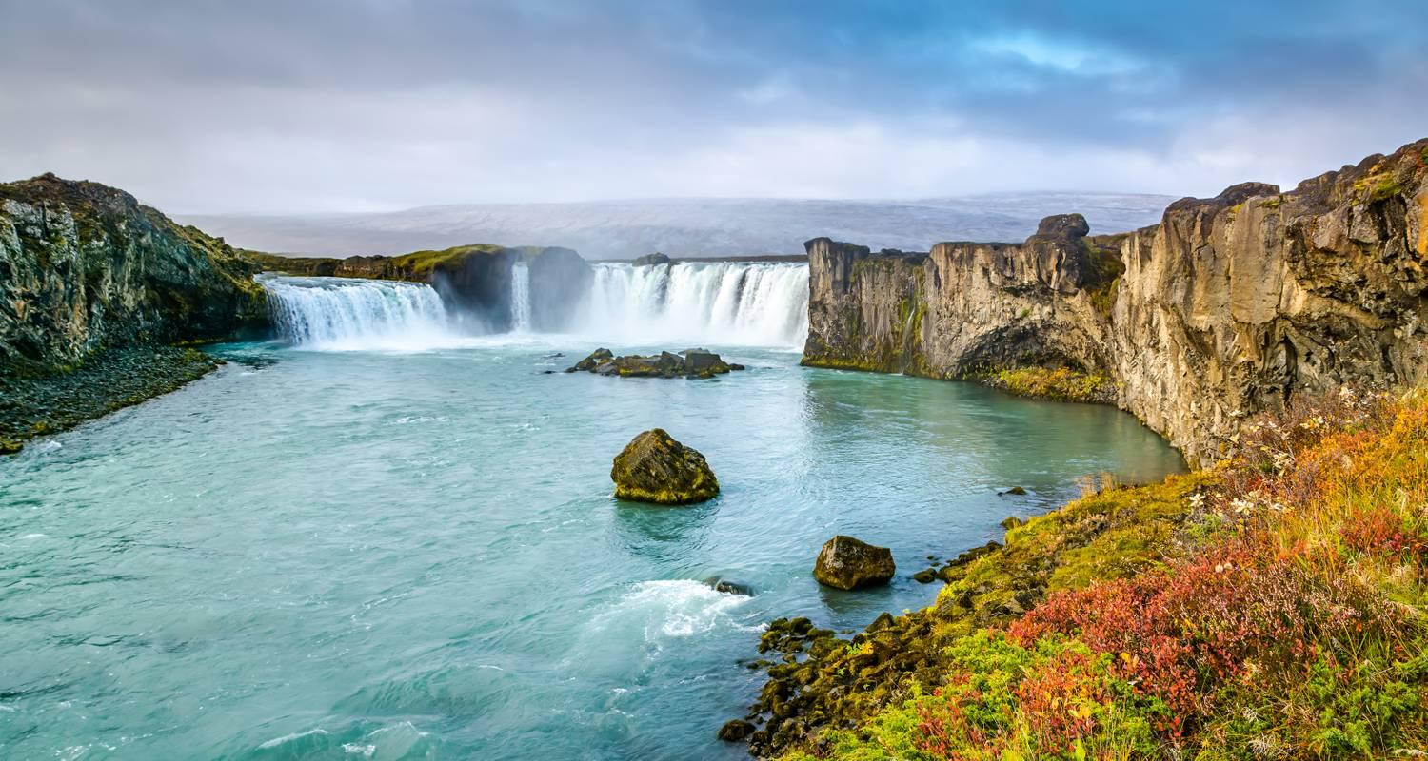

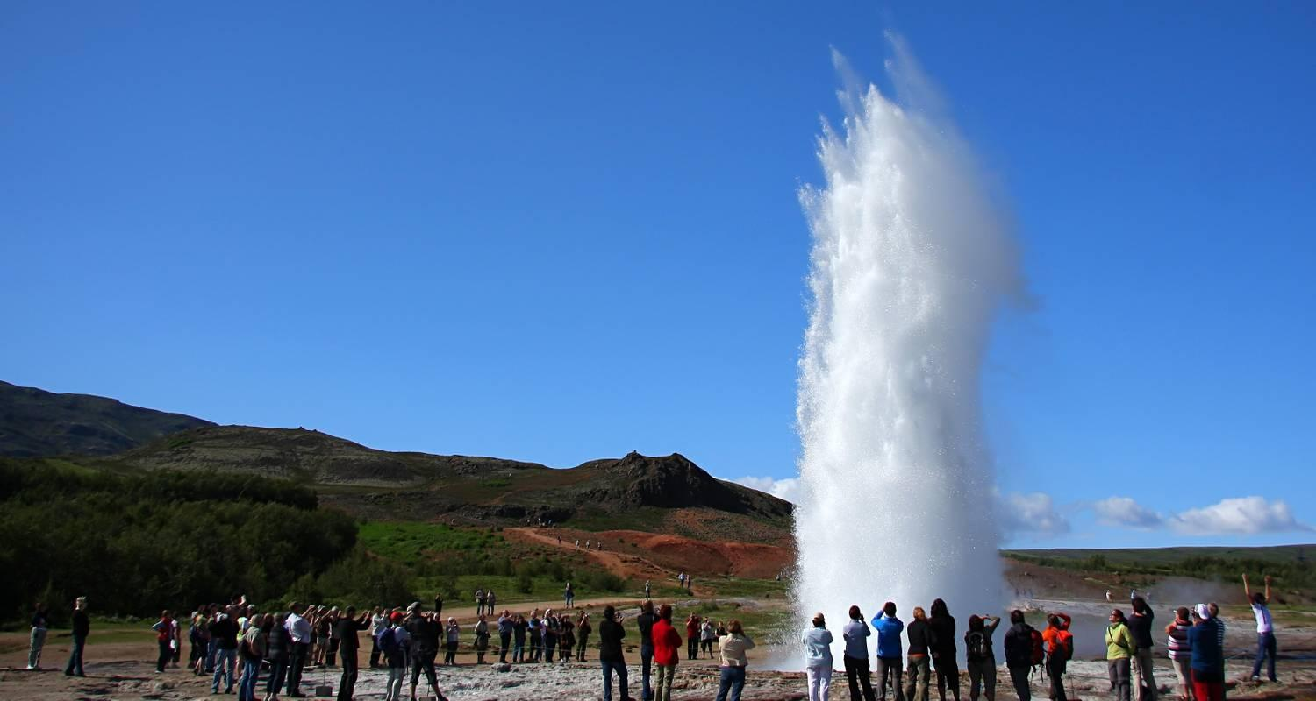

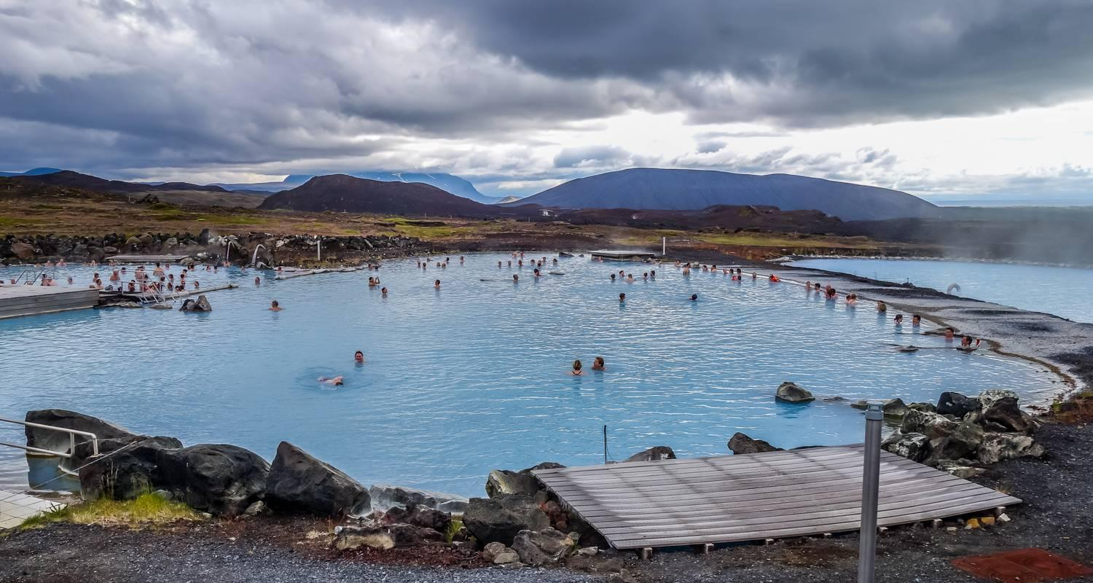

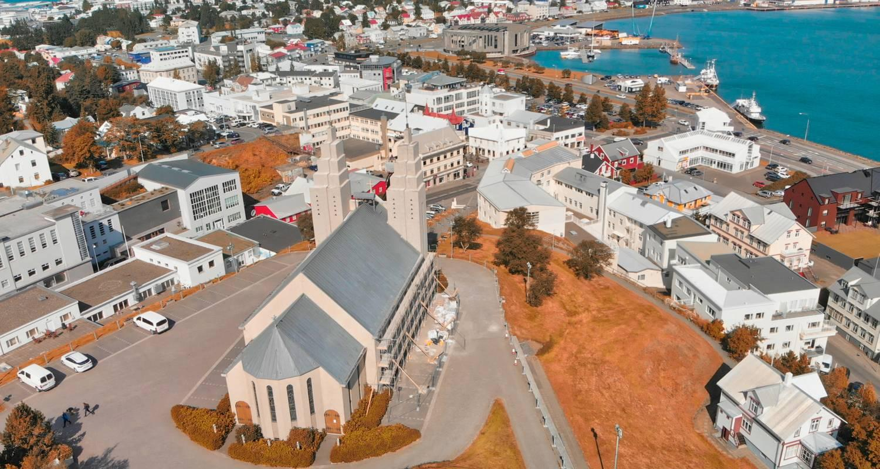

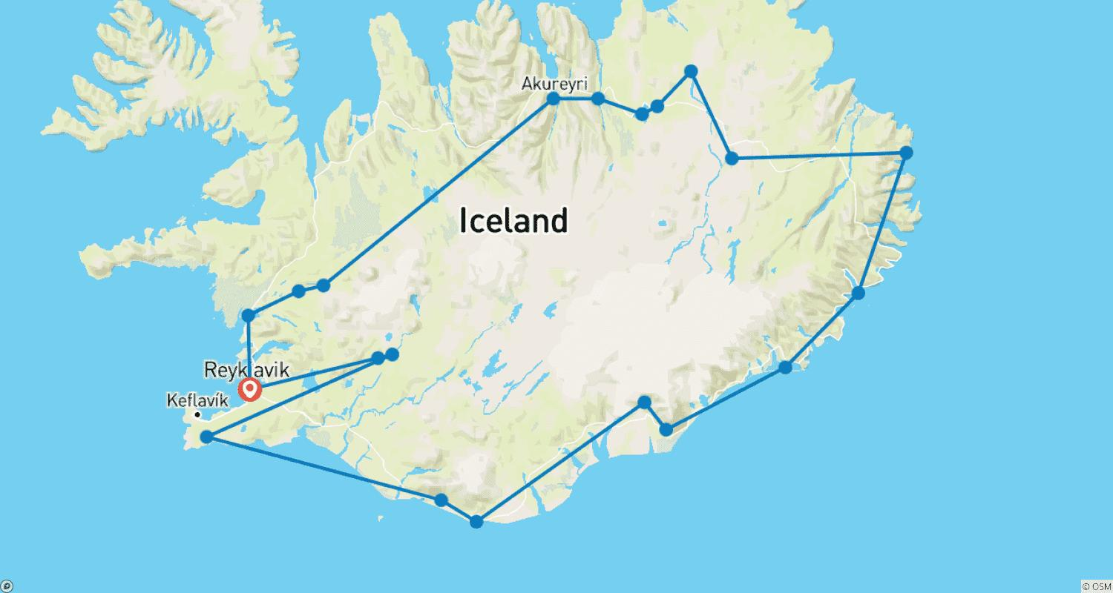

Tour ID: 240793  
Tour Name: Icelandic Explorer - 9 days/8 nights

Tour destinations: ['Reykjavik', 'Borgarnes', 'Godafoss', 'Myvatn', 'Dettifoss', 'Husavik', 'Modrudalur', 'Djupivogur', 'Hofn', 'Skaftafell', 'Hof', 'Reynisfjara', 'Skogafoss']

Tour destinations images:



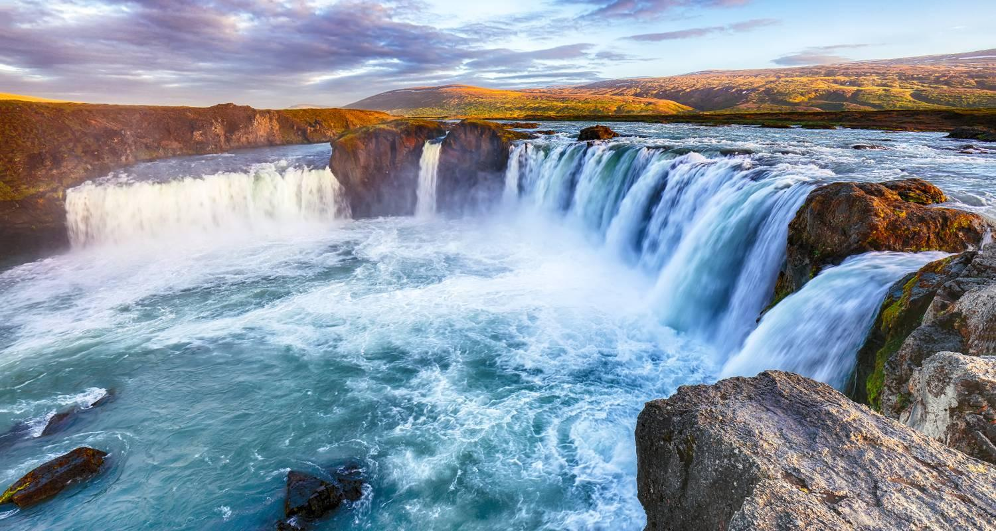



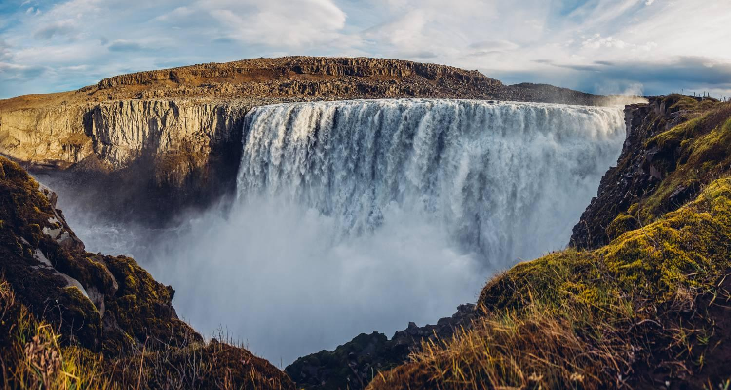

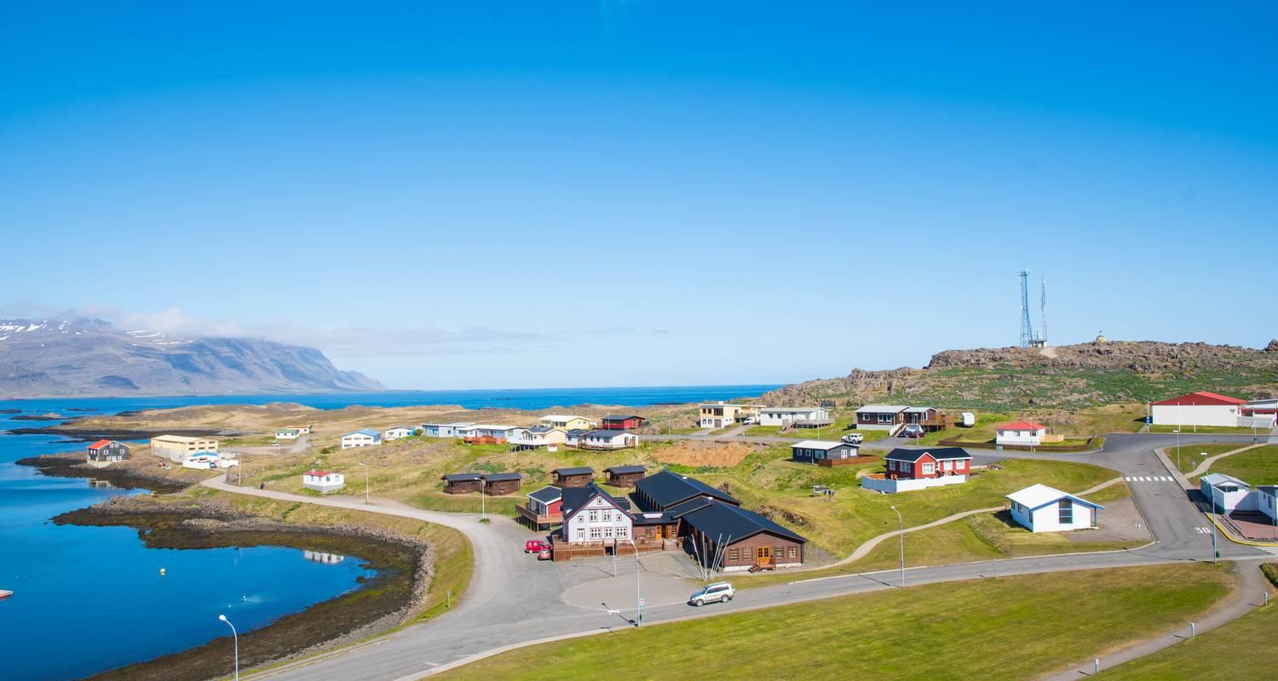





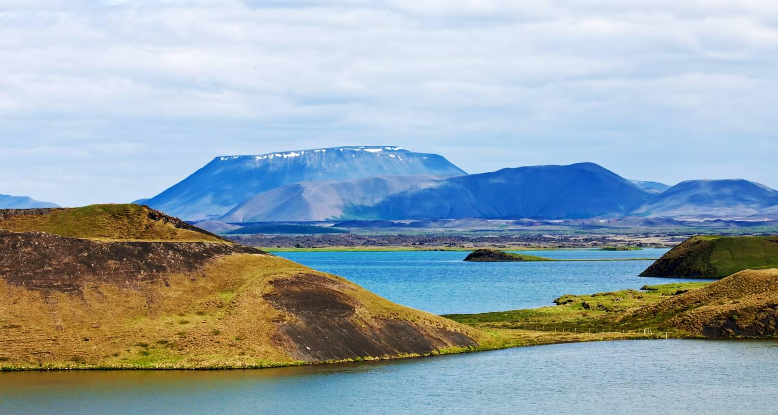

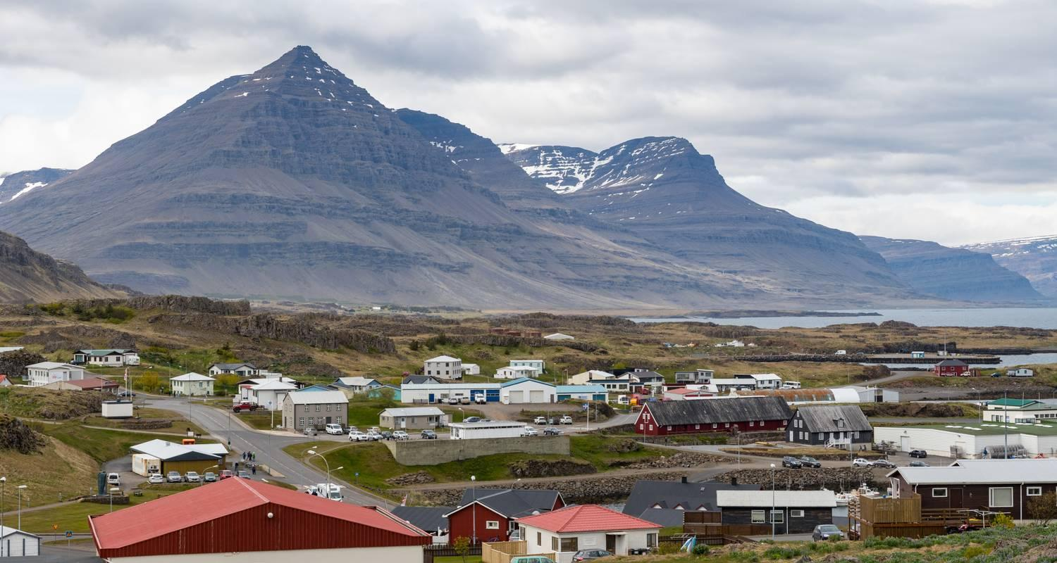

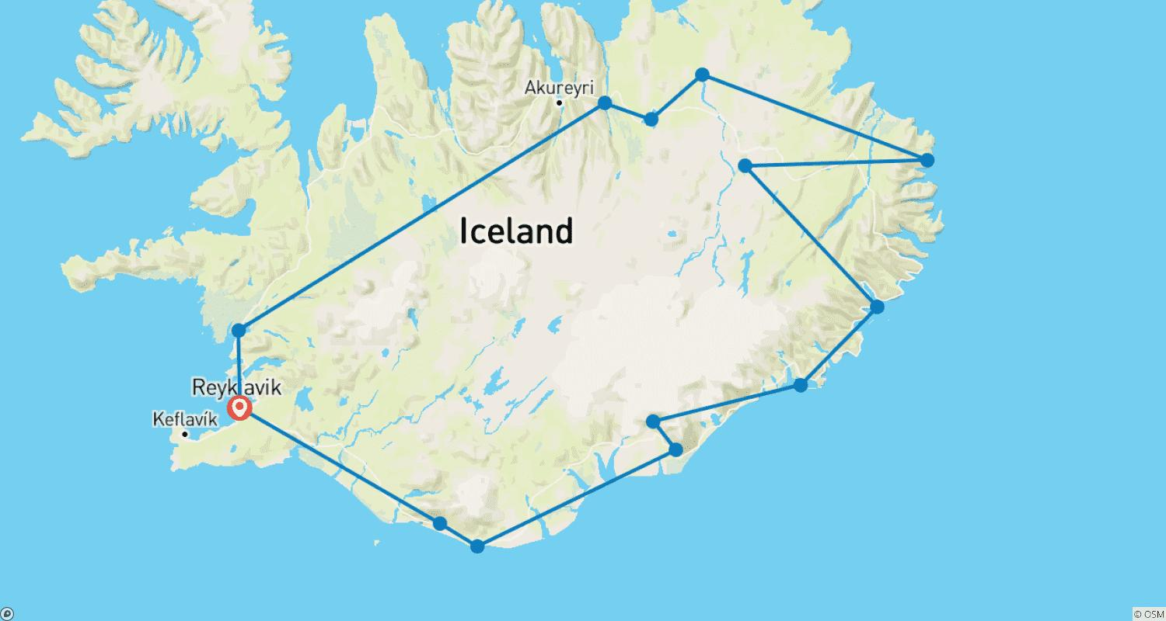

Tour ID: 241544  
Tour Name: Icelandic Adventure (2024)

Tour destinations: ['Reykjavik', 'Thingvellir National Park', 'Gullfoss', 'Husavik', 'Dimmuborgir', 'Akureyri', 'Snæfellsnes', 'Borgarnes', 'Húsafell', 'Blue Lagoon']

Tour destinations images:

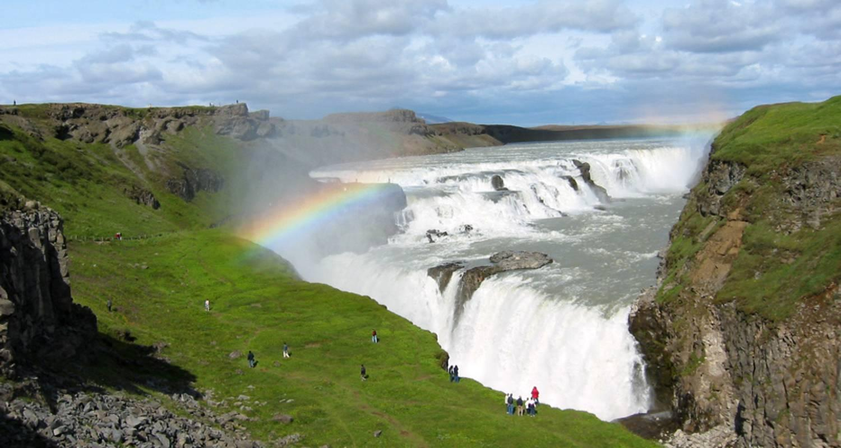



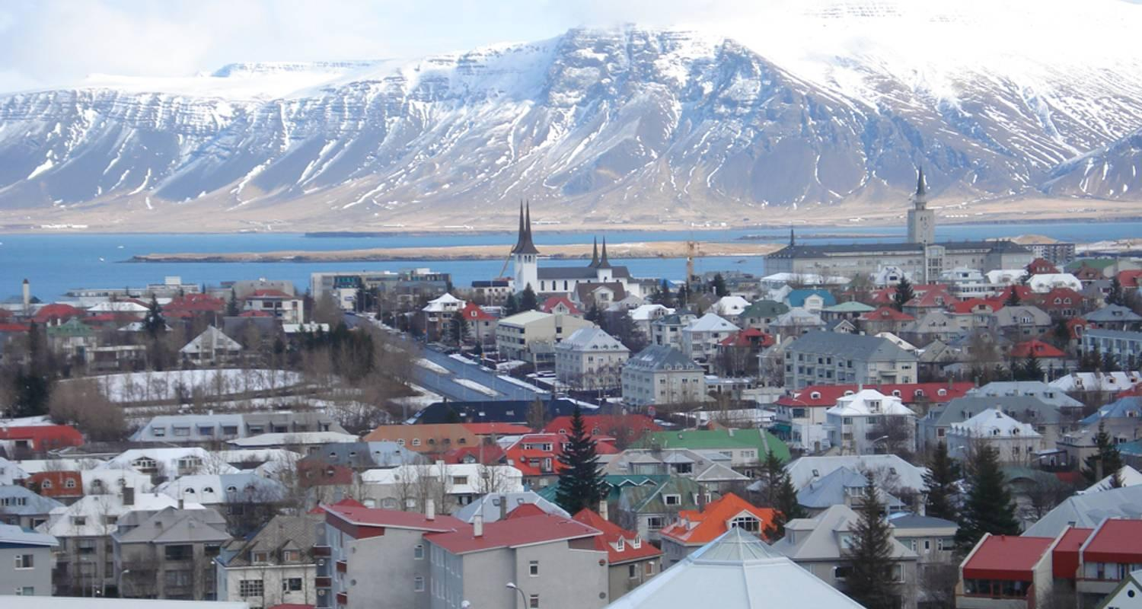

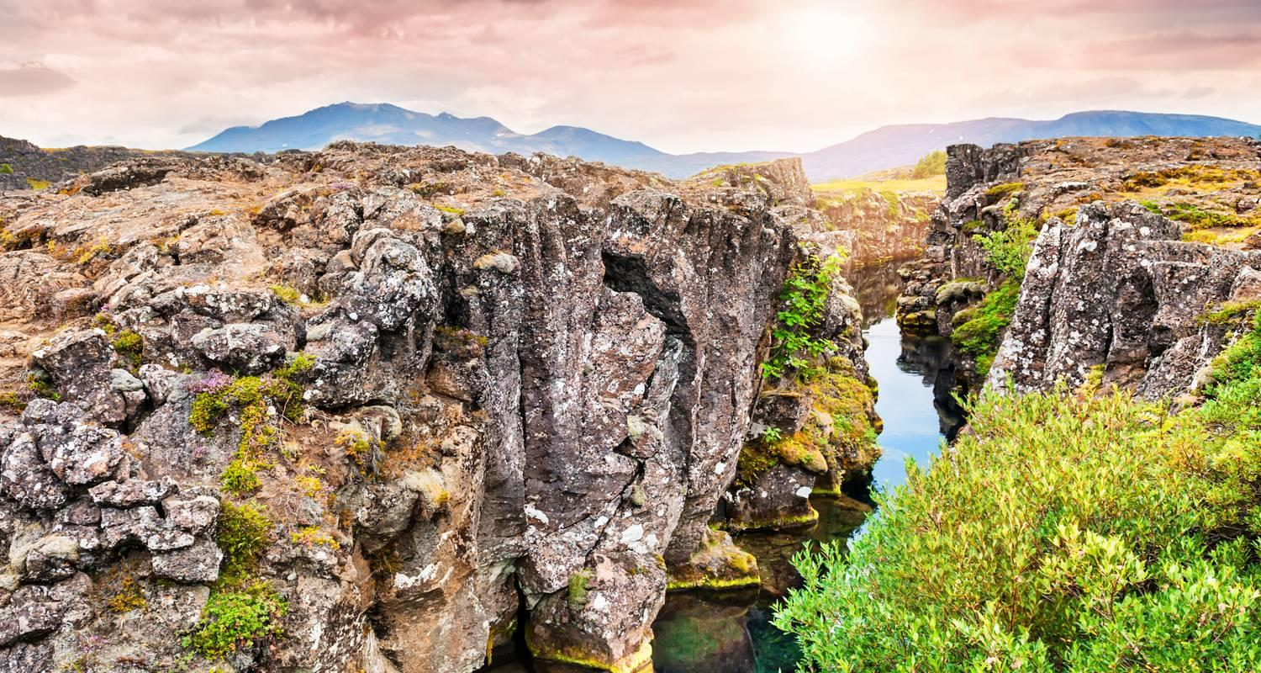

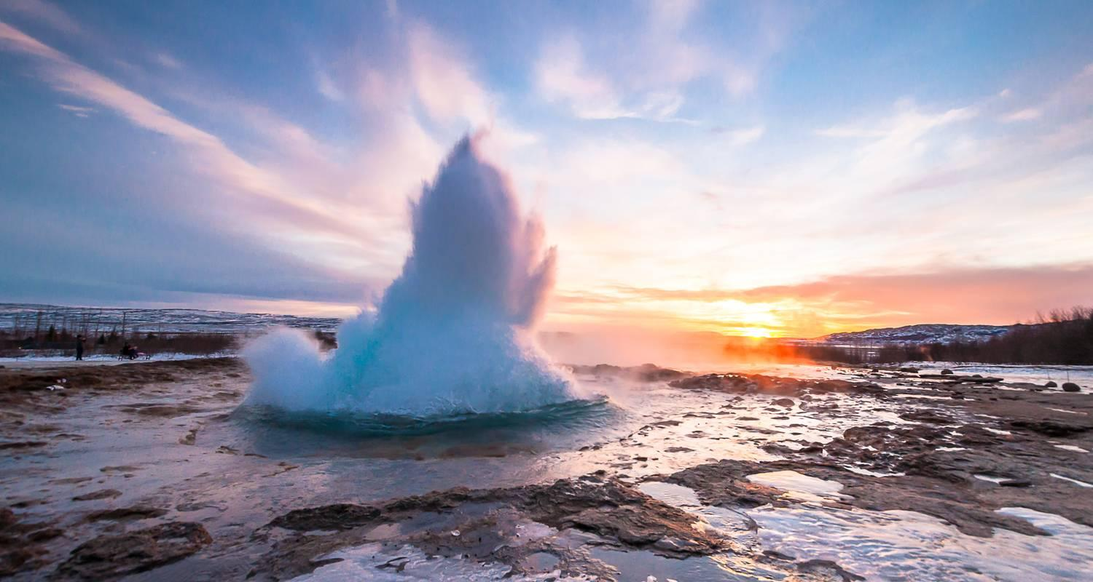

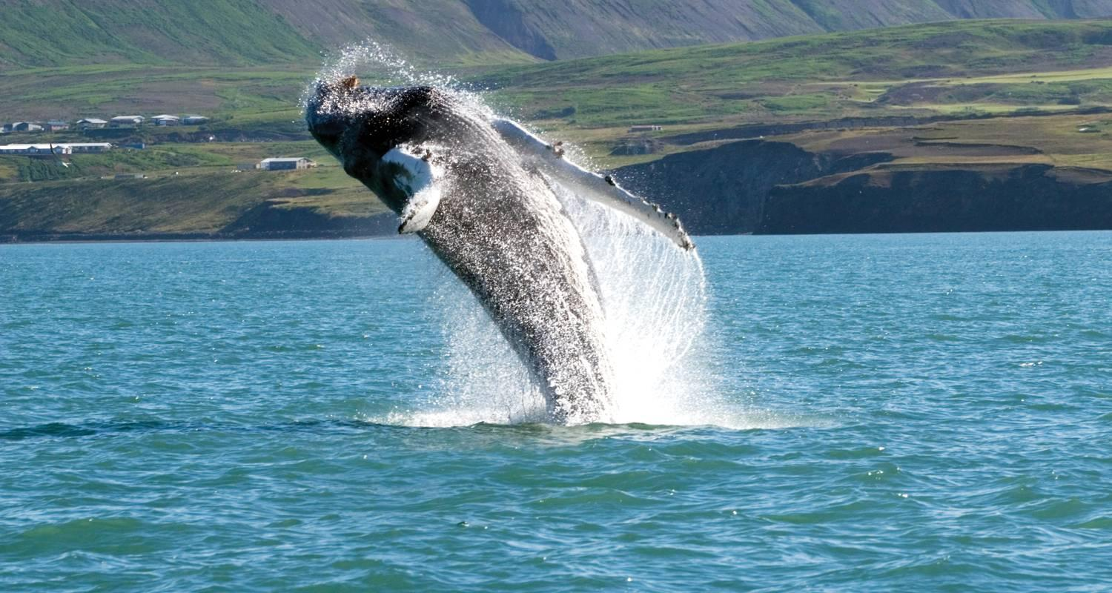

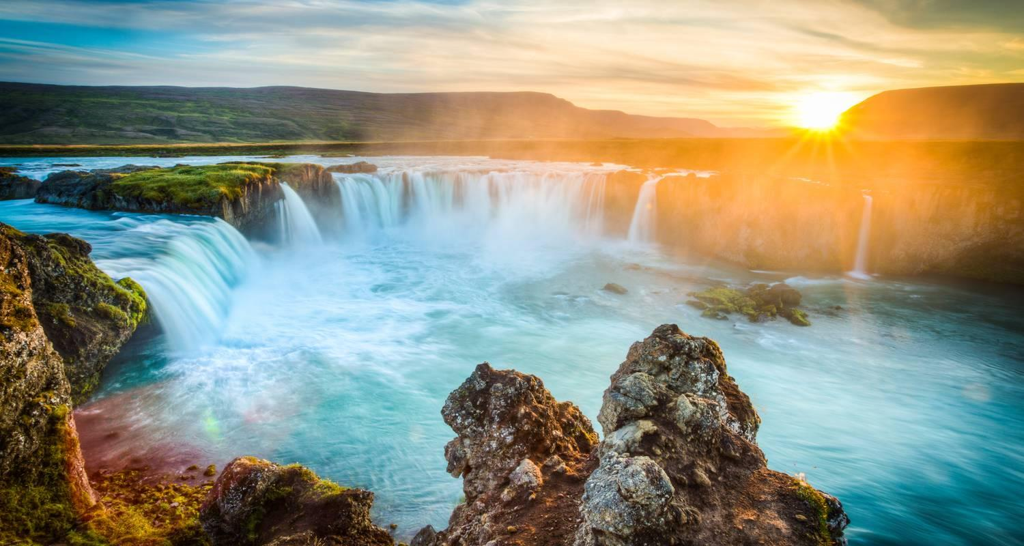

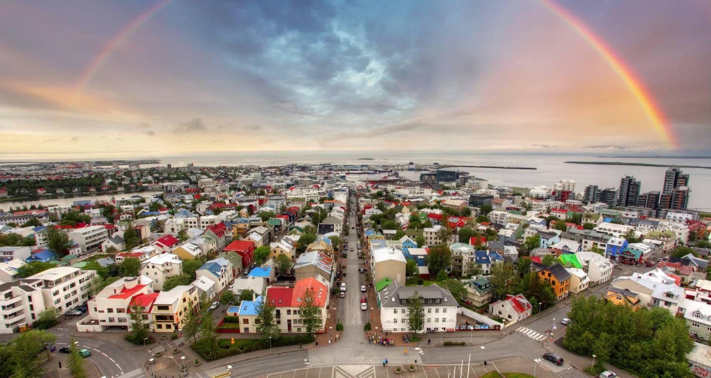

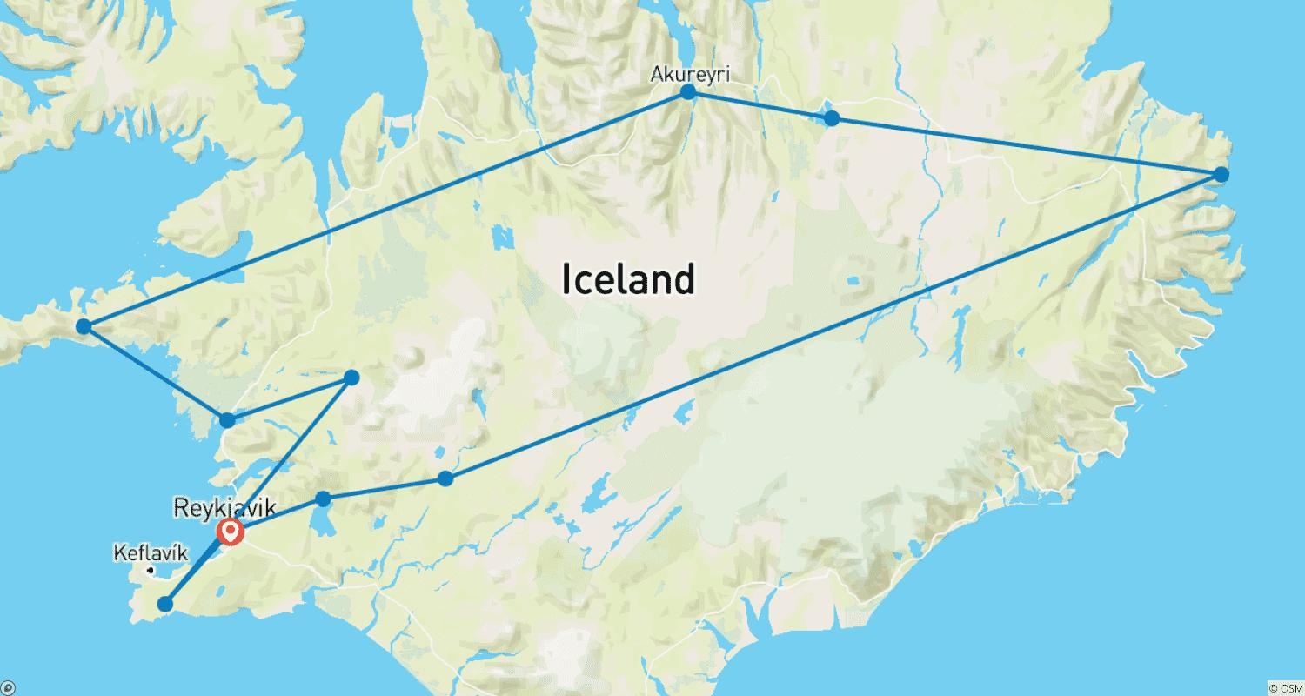

Tour ID: 241706  
Tour Name: Land of Northern Lights

Tour destinations: ['Reykjavik', 'Blue Lagoon', 'Vik', 'Gullfoss']

Tour destinations images:

